# Generate Theories with Bob the blob

Like air pressure, some science ideas are tricky! But if they work, we have to use them!

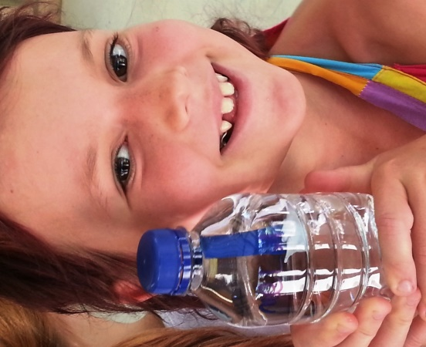

## Materials

An empty, see- through soft drink bottle (with a lid)

A modelling balloon

Some Blue tack (or similar pliable and also water durable product)

A large cup (filled with water) – see through cups are very useful here

Water, and probably a kitchen sink – be sure to watch every drop!

Too Light!!

Just Right!!

Too Heavy!!

## How to make a bob the blob

First, you need to make your diver Bob: but to get it right he’ll need to have just the right balance of air inside and weight underneath.

1. Tie a small bubble of air inside the end of the balloon and cut off the end. Balloons like to float anyway, so the bubble should be small.

2. Place a glob of blue tack underneath the knot.

3. This is your Bob. Float him in the water filled cup: If he sinks straight to the bottom, take some blue tack off. If he floats right out of the top, add more (see diagram below).

4. It’s just right when the Bob the blob just pokes out above the water line.

6. Next, fill the soft drink bottle with water right up to the very top, so that it's spilling out.

7. Drop Bob gently into the bottle.

8. Screw the bottle lid on tightly.

And there you have it, your very own

Bob the Blob the amazing Bottle Diver!!

(Remember to take him out when not in use!!!)

## Squeeze the bottle

What happens to bob?

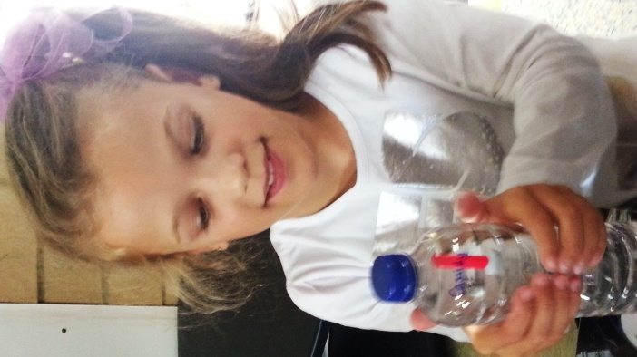You can play a trick on your friends – tell your friends that Bob is really alive, and you can prove it! Try clicking (or banging) the fingers on your hand that you don’t use to squeeze the bottle, and Bob will swim down anyway. Is he alive? Or is this just a trick. Have them come up with ideas of how the trick really works. Do you know what we call ideas of how the world works in science?

### Theories

Yes, lovely, helpful theories. And the best thing about science theories is that they can all be tested!

1. Are the sound waves from the click somehow making the bob fall? Experiment on this theory using a silent nod and you can still make it work.
2. Is it simply a matter of timing, and that he’ll rise and fall all on his own? Can you think of a way to test this?
3. Theories are the mind and brain of science. Can you think of some other theories of why this works?

Of course, they’ll figure out you’re just squeezing the bottle eventually.

But just as science begins with questions, it ends with them as well! For example: Why does squeezing the bottle make Bob the Blob float downwards?

### Who came up with this idea?

Much of the credit goes to the ancient scientist Archimedes. You know, who in trying to find out of the kings crown was made of pure gold finally figured out how to measure volume of irregular objects using water in a bathtub, shouts ‘Eureka’ and almost runs, reportedly, naked down the street with excitement!!

Our science answer is called “buoyancy!”

## Why it works:

1. The water is trying to push Bob the blob up. Ever noticed how things feel lighter in water? Water always pushes things up: the more space they take up, the more the water tries to lift them. You can feel this by trying to push a balloon full of air into a bucket of water. The more water you push out of the way, the harder it gets to push the balloon down!

2. However, Bob’s own weight is pulling him down (due to gravity).

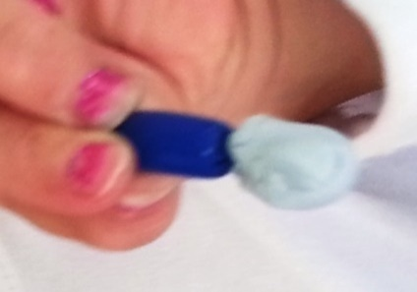3. When you squeeze, the water in the bottle squashes the bubble of air in bobs head smaller. This makes Bob smaller, even though he still weighs the same. This makes him sink in the water. (Relieve the pressure, he gets bigger again, and the water’s constant push up is strong enough to lift him again).

Gravity is pulling him downwards…

Buoyancy (due to water pressure) is pushing bob up.

### Not complicated enough?

1. Water pushes things up. That’s right, put anything in water and it tries to push it up. Even something that sinks to the bottom is being pushed up by the water around it – just not enough to make it float. This is due to Water pressure. Pressure is the squeeze you feel all around you as, say for example, you swim deeper and deeper into the water, or you feel less air pressure as you fly higher and higher into the sky (such as when you feel your ears pop in an airplane). Now, the water at the bottom of the bottle has more pressure than the water at the top (because it has the combined weight of the water above pressing down on it) This means that all objects in water experience an upward push as the water below is squashing them harder that the water above. This push up is equal to the weight of the water the object pushes aside, or ‘displaces’. This push or force is called ‘upthrust’ - the more space an object takes up the stronger the upthrust will be.

2. However, Bobs own weight is pulling him down, due to gravity. (It’s pulling the water down as well, otherwise, there would be no upthrust, but don’t let that confuse you!)

3. Bob sinks if his weight is greater than the upthrust, and rises if the upthrust is greater than his weight. Why does he sink? As you press on the sides, the air bubble in his head get smaller (air is very squishy, unlike water). This makes him a little smaller and thus, he ‘displaces’ less water. Less displacement means less upthrust and as soon as his weight is greater than the upthrust and … down he goes!!

Can you make him float right in the middle…?

AMCONFUS

### How did they convince us?

Archimedes continued his research, and was the first to announce the laws of buoyancy over 2000 years ago, and we use them still!!

## Who will Win? Gravity or buoyancy?

## YOU decide!!