EXILES

The Hidden City

Character levels 0 to 30+
Draft only, March 2019.

By Dr Joseph Ireland
© 2019

Table of contents
Table of contents 2
EXILES – The Hidden City 3
Player handout 1 - Character Creation 4
The Home City 6
Appendix: Helpful paperwork. 10
EXILES 11
You are the exiles. You have no home. 11
Fame, infamy, and the reputation spectrum 12
The Orizon Crystals 13
Equipment log: 14
Player Handout – Player Campaign Map 15

EXILES – The Hidden City
You are the exiles. You have no home.
The first time you can ever remember hearing the story was when you were barely an infant, sitting safely on your mother’s lap, the tears caressing her eyes as she spoke softly of a place you knew she had only seen with her heart. Yet deep inside your heart you knew every word she spoke was true.
“Millennia ago, from a time not even your grandparents remember, our people lived in the mighty city of light. There was no sun there, not even candles, because the glorious light never stopped shining. People were happy there, and lived their whole lives in peace. And when they died, their bodies re-joined the light that shone day and night, and we could hear them speak if we really listened, so we never truly lost those we loved.”
“The elements themselves were our servants there. The stones would shape themselves new each day just to suit us, and the water could rise up so you could drink it. No enemy could come to that place. Nothing bad or scary. And beauty, light, power and wisdom filled every heart and home. Best of all, the Gods themselves walked among us as our friends, our protectors, and our exemplars.”
“But then, one day, something terrible happened. We don’t know how, but we know our Gods were betrayed. The Great Enemy came one day with his hordes of terror. He slew or enslaved everyone he saw, and the rest… he exiled! As a shattered crystal, in a single day the mighty city of light was split into a thousand shards, and scattered throughout the universe.“
“Now… our Enemy hunts those that remain for sport. Now, we don’t even know if we’re the last shard remaining of that once great city. In respect, the place we call home is named “Lauresia” – the shard of light, or just the City. But this is not our home, this is not where we belong. Somewhere in the universe is the place where our souls go to when we die. It is a city where the light never stops shining, that is our home… and we… we are the Exiles.”

Player handout 1 - Character Creation

The beautiful woman, with eyes that seem to speak of nearly timeless wisdom, speaks:
Great things await you young people. You must not fear, nor turn away from your calling. You will make important decisions, for the life and destiny of many people. You are chosen, kept back for an hour such as this, and your choices will have great consequences. But with choice comes responsibility. Do you accept this destiny the Lights offer you today?

You are the exiles. You have no home.

You are the citizens of ‘the City’: living in exile from a home you’ve never seen, hiding from the ‘Eternal Enemy’ who betrayed your gods and exiled your ancestors from the realm that was once your home. Now, he hunts across the multiverse to kill you and your people. Where ever you go, none must know your name or your people… or the enemies spies may find you… and they will come for you…

You live in a flying city, supported by giant crystals that hold the city aloft in space. But this is not your home, your heart yearns for a place: the city of light, that was destroyed long ago. Now the only light shines from the magical crystals which power the city. They also can create a defensive shield, or throw brilliant bolts of energy at your enemies. But for all these formidable protections your greatest safety is in secrecy. For you never know when, one night, the enemy may find your people once again…

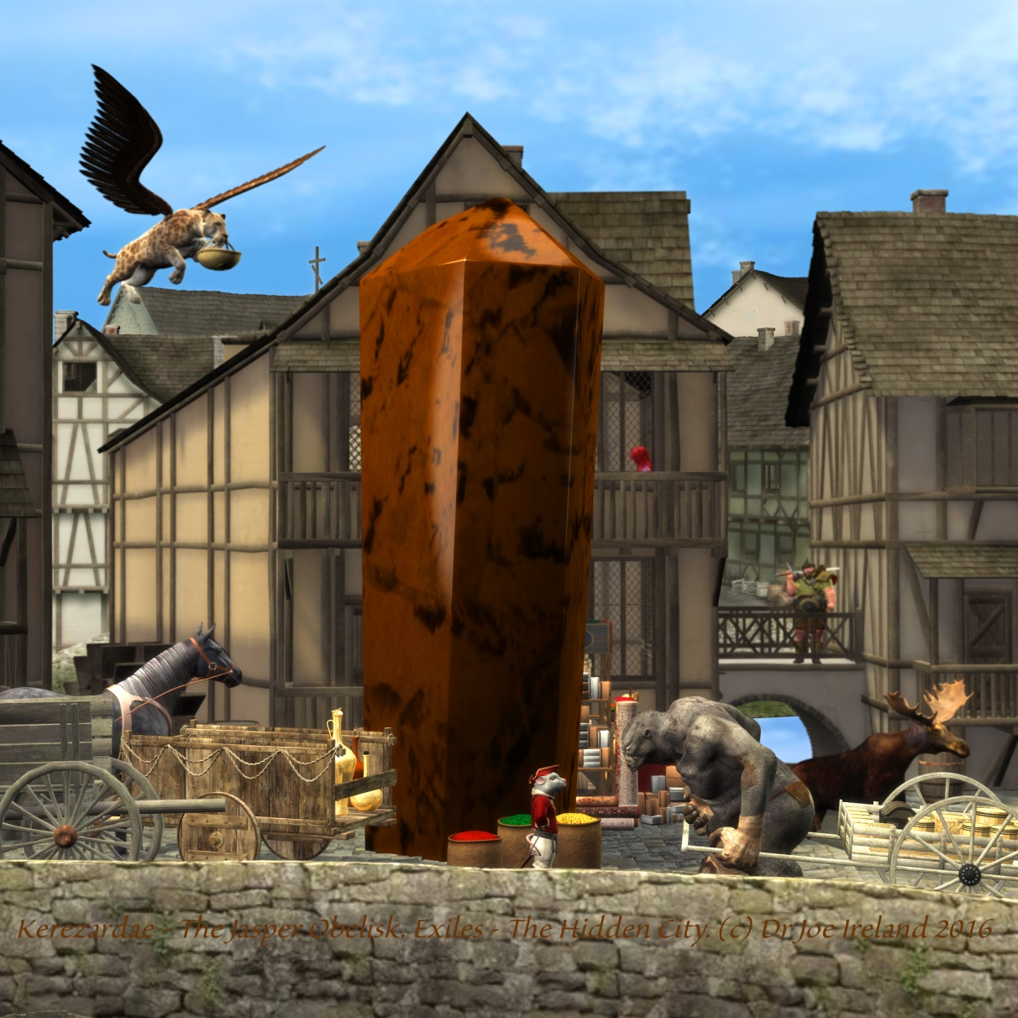
Character creation
The city is an eclectic place – gathering individuals, materials and knowledge from its travels all over the multiverse. This means just about any race, class or equipment is available at the city, pending DM approval of course!

Race choices
Standard races are recommended, as well as any that your DM inform you are allowed. Centaurs, dragon blooded and planetouched are all some possible possibilities.

Class choices
It is strongly recommended for role playing reasons that each character exemplify a different attribute, such as strength, dexterity or charisma (though it does not need to be maxed out completely.) If you don’t have six players, don’t worry. There’s always NPCs!
The game is set up based on the six attributes of the D&D 3.5 or Pathfinder systems.
It is recommended that each adventuring group have at least one divine spell caster, one arcane caster, a heavy hitter, and someone who can detect and remove traps. With the creativity of players (and the diversity of the builder books available), there are many more options than ‘fighter, cleric, mage and thief’.
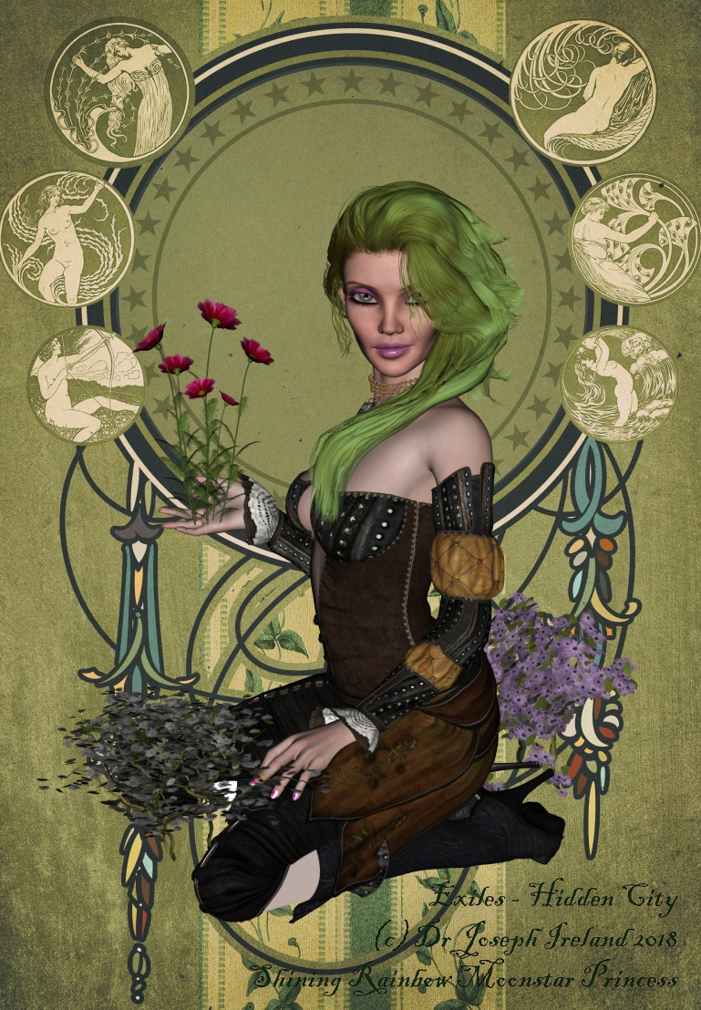
The most important thing to remember when choosing a class is that you get to play the character you want to.

Character roll up
This adventure begins at level 0 – when PCs are first youths at the end of middle school (schooling is compulsory in the city up to age ‘youth’). PCs must first choose the race, class and attributes scores they intend to take at level 1. You might also like to develop character background, traits and flaws. Other abilities, such as skills and feats, are revealed as chapter 0 progresses. By the end of chapter 0, or soon thereafter, you will have developed a fully level 1 pc.

Character background.
Coming from such a diverse people and city, the choices are almost infinite. There are even a few options for those who come from outside the city – picked up from war zones, or given refuge from the Eternal Enemy.
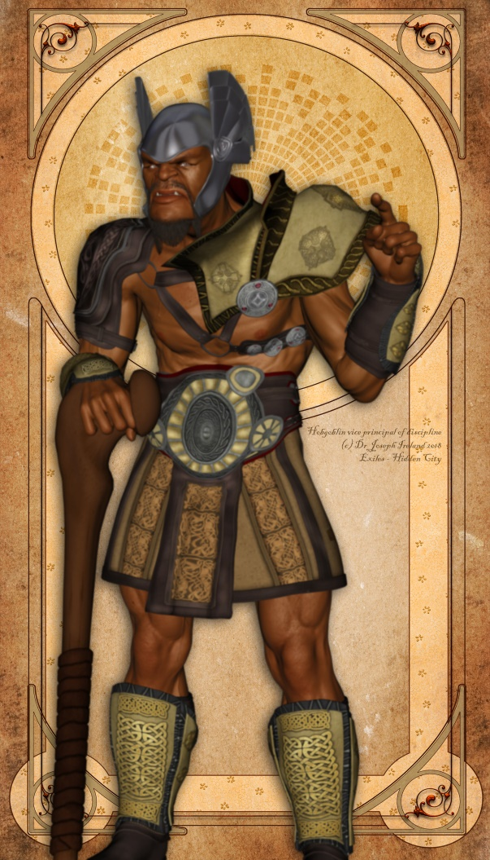

The Home City
Known as Lauresia, which means “the shard of light”.

Visitors to the city – which are few (PCs are unlikely to have never seen any), are at first impressed by two things. Firstly, the sheer diversity of races, cultures, architecture and even species. The city is a very eclectic place; a visitor may see a clever mechanical waiter serving at a timeless stone table where a drow and an assimar sit down to lunch, or bonded elementals power a furnace for smelting the iron the albino minotaur armor smith uses. This eclectic culture is a great asset, and information and examples of just about any esoteric weapon, class or race are available at the city.
The second thing visitors note is the high magic culture – most everyone knows a spell or two to do their job. City culture, history and society are heavily influenced by gemstones – even the streets are set in geometric patterns like carved faces of a diamond. The city is an almost unrivalled source of information, with a vast library filled with literary treasures from across time and the universe. Sages have been known to spend literally a lifetimes earnings just to study in the libraries for a week.
Yet the city has little in the way of primary production – not even enough to be self-sufficient – however, it does have a lot to offer in terms of skills artisans and magic item creation. Regardless of its isolated location, the city brings some of the finest gems smiths, potion brewers and craftsperson’s to be found. However, the city usually sponsors planar merchants to ship all wares in secret – so many are unaware they are dealing with the ‘Exiles.’
Children are all expected to attend school they finish their youth years. Elves (who spend up to 80 years attending school irregularly) tend to benefit more than half orcs (who frequently leave by 10 to pursue a trade). All youth are expected to follow a craft or profession. One rare profession allowed is that of the ‘hero’ – those specially chosen by the stones of the city itself to brave the world outside the protective walls. None have been chosen for this occupation for over a generation (of humans), and it seems as if this may so be for some time yet.
One drawback of living in the city is their intense social phobia of anyone not of the city – verging on paranoia. Even with all these skilled artisans and intellectual treasures, few outsiders will ever see the city and fewer even know about it – and those in the city like it that way. Those that wish to enter must undergo a powerful binding ritual which would slay them rather than have them willingly betray the trust of the city to the Great Enemy (a wish cast at 20th level). Those that leave the city frequently have their memory wiped clean of the experience. The city does, however, have a clear benevolence streak as they have been known to rescue other refugees or ‘exiles’ from war torn areas around the plains (adding to their kaleidoscopic cultural mix). As an added precaution, many fear to speak the name on any god lest they be heard…
Even those born of the city, who leave to trade on behalf of the others, are carefully chosen and tested. Even a stray word can be caught by the spies of the enemy, and if their original culture was destroyed in a day, then a single city would surely not stand an instant. But while fear of discovery is their constant companion, most citizens have adjusted to a happy life, even if the conditions are a bit cramped. It is better than the alternative…

Overview - City of the Exiles
The city: Republic integrated Small city, gp limit 17,000. Non adults 2400. Power centers: LG the high council. CN Shadow guild (rogues). NG order of the Illend (clerics), LN the military (fighters). Guards 340. Militia 1700. High level locals: Palayon: 14th level wizard. Lady of the Illend 14th level cleric. Master of Shadows 14th level CG rogue. Shim albino minotaur general, 6th level fighter. Approximately 200,000 citizens.

Once a part of a massive planar civilization numbering billions of citizens, the Enemy came and destroyed their ancient and glorious race and now hunts the remnants across time and space. Citizens of the city are descendants of this forgotten people or other exiles from other places around the Metaverse. While they have touches of advanced technomancy and culture from the hundreds of races they have visited, they are still in a state of decline, and have lost most of their original glory and culture. The city is overcrowded and unhappy, with internal politics threatening to tear the city apart. The city has been hiding in the astral plane for about a century and through its powerful (and poorly understood) magic and is in serious need of making moving venue. Maybe even risking the highly dangerous task of meeting and even trading with the locals. Its citizens must be wary, for should the enemy ever discover their location, they will come in great force to destroy them all…

Geography
See picture.

Military
The city has a standing army of over 2000 souls that also act as police, and up to 10,000 in times of war. However, all the populace are armed and well trained, most are at least level 4, so it is unwise to consider war with the City.

Daily life
Most racial tensions are set aside among the exiles, but old prejudices are difficult to forget. But by and large, most people get along on an individual basis, and don’t know what it means to live in a mono-racial culture. They are tied together by a mutual need to survive and the powerful enchantments that ensure most citizens get along. And then there is that tree people are fond of speaking to.

Government
The city is ruled by the high council of the wise: 12 rulers elected by the people from each suburb for making important decisions on law, policy and religion. Membership is for life, till the member announces retirement, or till a general vote of the suburb ends their membership. The Chair of this council can call on their double voting rights, and is voted in by the other council members to represent the white suburb. This council meets when necessary, about once a week, and otherwise things are just left to run by themselves. Some council members are very active in the community (such as Lady Illend) while others are popular but rarely seen figures (such as the current Chair, Palayon).

Religion
Citizens are relatively pious, however, they usually do not risk worshiping Gods, but the pure essences the Gods epitomize. There are strict laws prohibiting drawing attention to themselves by speaking the Gods names out loud – especially since the last set didn’t fare so well.
On Piousday the city comes to a virtual standstill while most people stay indoors. Those less religiously inclined claim to worship Industry (and keep working throughout the day), Revelry (and take the day off to party) or Serenity (and use it as an excuse to sleep all day). However, most citizens clearly value strength, beauty, light and knowledge as the four most valuable virtues.

Crime and punishment
Punishment: The most sever crimes are punished by imprisonment or death (and subsequent incarceration of the soul in a soul gem rather than release to any afterlife). There is no banishment. Several serious crimes may be punished by memory alteration, which also alters the personality of the person permanently. Punishment is generally carried out in the black, silver and gold suburbs.
Lesser crimes are punished though incarceration or repayment.

Origin of the people
By far the majority of people are drawn from the ancestors of the original citizens of the city of light, Lauresia herself being the only known survivor of the original destruction.
Refugees form the next largest group. Occasional residents come to the city as Lauresia is moved to compassion for their cause. More often than not as victims to the Enemies brutality to anyone who once trades with the city, and then does not inform him immediately and rat them out; entire civilizations have been laid waste thus. However, Lauresia has been known to rescue individuals from countless war torn worlds simply because they would have died otherwise. All then become residents, are magically compelled into never revealing their new people, and are cursed with the eternal hatred of the Enemy as well.
The final and rarest category is the defectors. Rarely an individual or people will attempt to flee the Enemy. Some have even been sent across time and space for the exact purpose of finding and betraying the Exiles – even if they are not consciously aware of it. Lauresia invariably detects such individuals, and faces a difficult choice: 1/ Destroy them, or 2/ Free them, heal them, and help them join the city. She never tells anyone of their backstory however, and all are left to assume they are simply another refugee. She won’t even talk about it with the traitor, unless they bring it up.

Cultural oddities
- This society is very eclectic – in clothing, race, beliefs, professions. The city has visited hundreds of worlds in its endless ages. One can find just about anything if you just look around hard enough.
- While distinctions of social class are generally discouraged, age is highly respected in City culture as measured by racial qualities (youth, adult, senior etc). Adults and supposed to defer to seniors, children to youth etc. Age ceremonies are standard among all races to announce social status, and social responsibilities. It is easy for locals to tell someone’s age category from their dress and demeanor. (Adult and older women wear covered heads, boys don’t wear vests etc.)
- The citizens of the city tend to greet each other with a courteous “How do you do?” The traditional answer is “Well, thank you” and anything else seems to throw them out. In what seems puzzling to other cultures, individuals from the city have been known to ask each other but then frequently don’t wait around for an answer. At other times, a citizen may answer this question even without being asked, simply on force of habit.
- When greeting new people or cementing business deals, they are also known for holding each other's hand and moving them in unison up and down anywhere between one and a half dozen times. This ‘hand shake’ is best performed with a palm perpendicular to the ground, and a hand tilted incorrectly may be perceived as dominance or sub ordinance.
- There is a movement growing in the city which believes the failure and distress they now face are a result of their failure to worship explicit Gods. They are starting to put pressure on to have the worship of the Greater Gods made the state religion.

City Map

Sky Market

Great Lake

Crystal

Towers

Garden of the Tree

Appendix: Helpful paperwork.

EXILES

The hidden city
(now with easy to read writing)

You are the exiles. You have no home.

The first time you can ever remember hearing the story was when you were barely an infant, sitting safely on your mother’s lap, the tears caressing her eyes as she spoke of a place you knew she had only seen with her heart, yet deep inside your heart you knew every word was true.
“Millennia ago, from a time not even your grandparents remember, our people lived mighty city of light. There was no sun there, not even candles, because the glorious light never stopped shining. People were happy there, and lived their whole lives in peace. And when they died, their bodies re-joined the light that shone day and night, and we could hear them speak if we really, really listened, so we never really lost those we loved.”
“The elements themselves were our servants there. The stones would shape themselves new each day just to suit us, and the water could rise up so you could drink it. No enemy could come to that place. Nothing bad or scary. And beauty, light, power and wisdom filled every heart and home. Best of all, the Gods themselves walked among us as our friends, our protectors, and our exemplars.”
“But then, one day, something terrible happened. We don’t know what it was, but we know our Gods were betrayed. The Great Enemy came one day with his hordes of terror. He slew or enslaved everyone he saw, and the rest… he exiled! In a single day the mighty city of light was split into a thousand shards like a broken crystal, and scattered among the universe.“
“He hunts those that remain for sport. Now, we don’t even know if we’re the last shard remaining of that once great City of Light. In respect, the place we call home is named “Lauresia” – the shard of light, or just the City. But this is not our home, this is not where we belong. Somewhere in the universe is the place where our souls go to when we die. It is a city where the light never stops shining, that is our home… and we… we are the exiles.”

Fame, infamy, and the reputation spectrum
As your characters achieve awards, they make friends (and enemies). Certain things you do you alter your reputation among groups. For each great deed you do, you can increase in level. Every time you bring dishonor, disaster, or insult to a group, your reputation will suffer. Of course, sometime forces outside your control, such as a bitter rival or malevolent deity, may act in a way that damages your reputation as well. Fame brings benefits, and infamy can make it hard to get around.
One’s fame, or infamy, can be represented on the following spectrum.
- Undying allegiance. +8 on diplomatic reactions. Unless dissuaded in some manner, the heroes are followed around by a significant crowd of at times a thousand individuals, waiting on the heroes every word. If they commit an evil act no one believes them even with undeniable evidence.
- Honor. +4 to interactions. The rich, powerful and famous are constantly extending dinner invitations. Especially restaurants, who will put up a sign ‘… ate here!’ You are often invited to be a special guest at important functions.
- Friendship. +2. Everyone want to invite you to dinner, and you presence always causes a bit of a stir.
- Respect. +1. Most people recognize you and have heard of you. Some may pose for photo’s.
- Association. No bonus or penalty on interactions.
- Distrust -1. People talk about you behind your back, and some are openly impolite.
- Infamy -2. Local authorities are quickly called when you are around, and they ask you to move on or arrest you.
- Ire – 4. A mob soon forms as soon as they realize you are around, and attempt to arrest you or drive you away. Bounty hunters occasionally cross your path. All allies and associates have a -1 on their level.
- Undying hatred. The mob will try and lynch you themselves. You are constantly hounded by bounty hunters and assassins while in the nation, and often outside it. All your known associates are questioned and treated poorly any time they are seen in the area, and have a -2 on their reputation levels. All good acts are disbelieved as part of your nefarious treachery.
Culture | Reputation | Chapter and event that caused current reputation level
Lauresia
Sultancy
Beastmen
Warlords
Skylings
Pirates
Tris

The Orizon Crystals
When you got it | Where you got it | How you used it

Equipment log:
Chapter  # | What it is? | Cultural heritage | Gp value | Where it is kept  (Or what happened to it in the end)

Player Handout – Player Campaign Map
Please answer the following in the most honest way possible

1/ My character’s name is;

2/ And he/she/its primary motivation for adventuring is;

3/ Along the way they hope to meet;

4/ And to acquire in magic items and powers;

5/ While I’d like to game every day if I could, the best day of the week for me to play D&D is:
6/ And I’d like to play every ______ weeks.

7/ And DM, I think you should know:

D&D table rules;

1/ Do not argue with the DM
The DM is always right. Even when the DM is wrong, the DM is right. Nothing the DM ever does is to the detriment of the overall story to your heroic character, even when bad things happen to them. Trust the DM. Respect the DM. Love the DM (generally speaking).
2/ Play for the group
Everyone loves their character just as much as you love yours, potentially. So plan your play so that the whole group has fun, not just your PC. The DM pledges to respond positively to all respectfully phrased and benevolent suggestions for how to improve the group’s game.
3/ Keep combat moving
Please do not slow the game down by ignoring everything during combat and only paying attention when it’s your move. A two minute time limit to your turn in combat may apply, or your PC will ‘delay’. You might also like to roll damage and attack dice simultaneously.

