Space Chase 3: Daniel
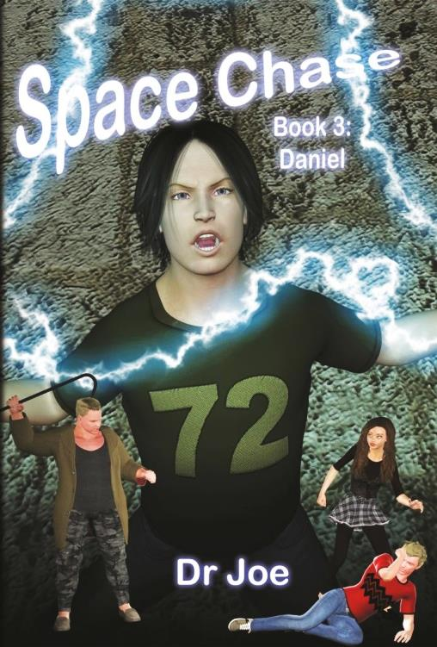
ISBN-13: 978-1519781819
Publication date: 1 December 2015
Size: 15.24 x 22.86 cm
RRP: $16.99, paperback
Extent: 128 pp paperback
Target Audience: Young adult, middle school,
children, science fiction.

Book 3 in “Space Chase” Series
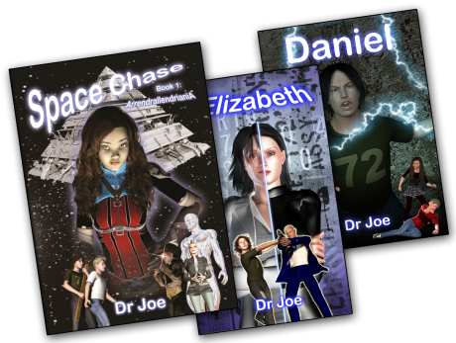
Also available
Book 1: ISBN-13: 978-1516993543
Book 2: ISBN-13: 978-1530734078

Buy the book, or even the entire series, online at www.DrJoe.id.au
Teacher notes and first chapter reader available!

Book 3 of the Space Chase science fiction saga (~lexile 750) National curriculum outcomes: science content (optical illusions). Creative and critical thinking. Resilience and dealing with bullies.

It wasn’t easy being Chase. First, his dad was crazy; filling their home with broken dreamcatchers and used incense sticks. Of course, his mother was crazy too, but in the complete opposite direction. She worked twenty five hours a day and never came home. His brother was always getting into trouble and, let’s not forget, his best friend was an alien.

Daniel is the third book in the series, Space Chase, which explores sound scientific concepts within the framework of an engaging science fiction narrative. This story focuses on the sciences of the mind & personality, while a young man finds himself on the cusp of dangerous new powers.
‘We loved reading “Daniel”! Exploring different optical illusions was lots of fun. We liked looking at them from different viewpoints and talking about them together’. Dallen and Edan Jackman.
“Very awesome and amazing and once you start reading you just can’t stop!!” – Sarah Ireland.

