Creating Science

The hands-on inquiry science professional development program for early childhood teachers.

Program notes. By Dr Joe Ireland.
(© 2018 Joseph Ireland)

All activities and notes available online at www.drjoe.id.au,
or can shortly be by request.

Reviews:
Thankyou for teaching me a valuable lesson on making science fun, engaging and interactive. My students will benefit for years to come keep on teaching children to explore their worlds. - Jade

Science is fun for kids! Enjoyed the presentation. – Susanne, Springsure

It was all good, the group discussion was great. [I felt it] was a different way to think about science [teaching].” Philippa, FKA.

“Thanks for helping me think about how to ‘do’ science. I think I tend to get suck in the ‘show’ science phase.” Lana C&K Magnetic Island.

The philosophy of science in teaching
Q: What is the first thing a scientist needs?
A: Questions: It starts with questions. It doesn’t start with activities, it doesn’t start with science gear, it doesn’t even start with an aim. It starts with questions. (Demonstration of the returning roller).
- Write down what you think is meant by the phrase “Scientific knowledge is created.”

- Scientists and students make understanding. Just like politics or crime research. (Science as argument.) Scientific knowledge isn’t “discovered”, and we don’t think it’s revealed. A postmodern perspective informed by constructivism holds that we must make up the science. Therefore, scientific knowledge is created.
- And even more importantly in this context, scientific knowledge is being created and recreated inside the minds of your students every day!

How scientific knowledge is created.
(for example, using the air powered rocket)
- Questions
- Theories
- Experiments
- Conclusions
- Communicate
(There is more to that, but it will do for our purposes today)
Most impressively, this is the Australian national curriculum

Science for social reform
Help students see the purpose of science
- Find a cause or problem they are passionate about
- Research it, look for solutions
- Test out the solution
- Come to a conclusion
- Tell everyone why it matters!

Points to ponder from the scientific glossary:
- Experiments are made to test ideas (specifically, theories).
  - Experiments don’t “fail”.
  - Science is based on evidence, not expert opinion (who, what, how).
  - Science is (Observe), question, explain, predict and test, conclude, publish. Not aim, material method etc., that’s experimental write-up so that others can try out your science.
- However, did you know that experiments aren’t the only way to do science!
  - Lederman (2004) cites 3 general levels of scientific inquiry; Descriptive (closely observing a situation, common to anatomy and taxonomy for instance), Correlational (comparing information for patterns, common to sociology for instance), and Experimental (discussed here as creating and testing ideas about the world).
- Experiments aren’t demonstrations (testing a theory v’s demonstrating it).
- Experiments aren’t tests (testing a theory v’s just seeing what will happen).
- Fair tests are experiments set up so that we know what we’re testing!
- Theories aren’t guesses. They are explanations or, in my words, ‘science stories’ of how the world works. Scientific theories can be tested. Theories include the theory of gravity, theory of evolution, or germ theory.
  - Theories usually start with the word ‘because’…
  - And require evidence to be accepted in science.
- (Hypothesis aren’t predictions. Predictions are guesses at what your results will be. Hypothesis are baby theories that haven’t been tested much or are based on only a few observations. Hypothesis can grow into well accepted theories if they pass many tests.)
  - They also usually start with the word ‘because’.
- Scientific laws aren’t “true” – they are just another kind of theory that must be tested, and will be rejected if they fail the tests. Scientific laws are used to specify a particular relationship in nature, and are usually written using mathematics. Laws include the gas law which explains the relationship between pressure and temperature, or the laws of motion which explain the relationship between force, mass and acceleration.
- Observation isn’t inference. What you perceive (observation), and how you make sense of what you perceive (inference) are very different things.
  - The rocket balloon flew around, that is what you observed. But why did it fly around? That is your inference, or in other words, your theory.
Demonstration of Bob the Blob.

(Extra bonus from the philosophy of science)
- There are two very general bodies of science: core and frontier.
  - Core science is very well established, used and agreed on by large numbers of scientists, and resistant to change. Core science includes atomic theory, genetic theory, and in spite of protests to the contrary – evolutionary theory.
  - Frontier science is new, often hotly contested, sometimes controversial and for that reason much more popular and publicised than core science – making many people feel that frontier science is the only science.
Demonstration of the rocket balloon (some science concepts are crazy, but they work, so we are obliged to keep them).
(Back to the curriculum then!)

Science is a people activity;
- Who invents a theory matters; what’s their background, motives, experience?
  - Every science idea ever created was done by a person – who?
  - What motives did they have? Were they honest motives?
- How they say it matters, what evidence they have?
  - Science ideas must be tested before accepted (this is one way science is different from other ways of knowing).
- What are they actually saying, what does it mean?
  - What did they teach us? Was it electricity, motion, air pressure?
  - Can this new knowledge be used to predict or work with nature?

Surprise, this is the new curriculum!
- Human influences (who)
- Inquiry skills (how)
- Content (what)
Demonstration of the Puff Bottle.

So what is inquiry? Review of Ireland et al. (2012)
There is a lot of fuss about this ‘inquiry teaching’, so I did my doctoral research to find out what teachers meant when they said “I’m teaching science through inquiry.” I found there were three things that teachers actually meant;
- Inquiry as experiences – making science engaging and hands on.
  - Examples: Plants in cupboards or worms on tables.
  - Goal: to make science fun and science concepts tangible.
- Inquiry as problems – helping students to be problem solvers.
  - Examples: Inventing levers or timing ball bearings in liquids.
  - Goal: develop student confidence as independent problem solvers.
- Inquiry as student questions – helping students to ask and answer their own questions.
  - Examples: Learning about ‘under the sea’ or rocket balloons.
  - Goal: help students to ask and answer their own scientific questions.
Each conception had its benefits and place in the curriculum, however, those teachers which focused on helping students to ask and answer their own student questions were describing a curriculum that was more aligned with contemporary educational objectives. Also, the categories were hierarchical, experience centred teachers tended to stay with simply experiences, while question centred teachers would use all other conceptions at different times.
Questions are the basis of science. Questions not only help you to determine what students are actually learning; the questions you, your students, and future scientists ask will determine what science becomes in the future.

Activities to try with kids (and associated paperwork online!)

Not all questions help in science
Some questions are simply for attention, others are beyond the scope of science, while others are quite scientific but we simply don’t know the answer.
- Say, “I don’t know, but we can find out!” While it may not so be in politics, not knowing is a completely acceptable state, and response, in science (and education).
- Say “That’s a great question but we don’t have time to get into it right now, maybe you can write in your science book?”
Not all questions are scientific.
- Some are ‘philosophical’. “How do pets die” might be a valid scientific question involving disease, accident prevention and all kinds of topics. “Do pets go to heaven” is not a scientific question. Another example; science can tell us that we can build an atomic bomb. But it can only inform, not answer, the questions of whether or not we should (and if so; where and how should an atomic bomb be used).
- If it doesn’t generate a testable prediction, it might be about science, but it is not a scientific question. For example; the theory that the door opened due to the action of an invisible, inaudible, undetectable by any means, magical purple dinosaur. Such a theory involving the undetectable can never be tested. As a teacher you may still consider the theory worth writing down in the interests of validating student engagement – and, let’s face it, every day the untestable becomes testable due to increases in scientific understanding and technological prowess.
- Some are research questions; you need simply look up the answer. For example, “Why is pluto no longer a planet” is a simple research question, not a scientific question – until new knowledge is created from the data gathered, and tests then may be proposed to consolidate that knowledge (and thus, further research is required).

Activity: Question Quest.
In the centre circle, write down ways in which you can put student questions at the centre of your curriculum – or throw them in as paper aeroplanes… For example;
- Have an engage activity and write down student questions.
- Have a question book and leave it open, or a poster, or a page in their books.
- Have a wonder corner where they can redo activities in their own time.
- Have free time at recess.
Practice with a rocket balloon or similar activity – it all makes questions!

Created conclusion
However… even a question centred curriculum is not enough. In the study teachers still fell short of helping students to become creators of scientific knowledge, as opposed to engaged and entertained consumers of scientific knowledge (Ireland et al, 2012, 2014). Knowledge was waiting to be found by accessing the right expert, activity or experience as opposed to being generated by students and tested by their own efforts.
Look again at your definition from the start of the phrase “Scientific knowledge is created.”
- Science is all about generating questions and testing ideas. When a teacher is presenting science as ‘facts to be memorised’ rather than ‘ideas to be tested’ they might be teaching about science, but their students aren’t doing science. How can we help our students become testers of scientific ideas, rather than memorisers of other people’s
Suggestions for informing science education from a constructivist framework.
- Instead of just doing a demonstration, PAUSE to ask what they think will happen and why.
- Get students to EXPLAIN their results. Have them JUSTIFY why they choose to believe this. This is what it takes to make science as an argument (I prefer debate).
- Don’t be afraid to NOT KNOW. Science begins with not knowing (i.e., with questions). Honest ignorance is always better than false knowledge.
- STOP to explain who came up with this theory, and how they convinced the world. Theories belong to people!
- MAKE your explanations tentative – just like real science. It’s not about memorising other people’s ideas, but about learning why and what and how they convinced us… and if they’ve convinced you! (see Sandoval, 2005 or Furtak, 2006). There are other good reasons to be ‘tentative’:
  - Even the best teachers are sometimes wrong – not only are we subject to misunderstanding, but knowledge itself changes over time.
  - Science itself is open minded, and ameliorable to change. If we can’t be, then we’re not really teaching science.
  - In spite of your best efforts, some students will still misunderstand a scientific concept. But if students understand the importance of being open minded, their ideas are open to change, as opposed to them digging in or simply giving up because they ‘never get it right.’
- Encourage questions! Ever answer is really just a new question in science!
Let’s help our students become creators, not just consumers, of knowledge!

Extra activities
- Balloon rockets (fair test and investigation of variables)
- Co-efficient of bouncing (fair tests and exact measuring)

Websites you must know:
http://drjoe.id.au/index.html my place online, the best place for fun learning hands on science shows!
http://www.australiancurriculum.edu.au/Science/Rationale where to find the curriculum online.
http://www1.curriculum.edu.au/science/index.htm some dated links, but useful non-the-less for units and PD materials.

Websites on science content
(a growing list)
http://www.qm.qld.gov.au/Learning+Resources/QM+Loans Queensland museum will actually let you borrow some of their gear! Get some neat taxidermy, ancient tools, or sweet hands on science toys!
Space: visit the Brisbane planetarium http://www.brisbane.qld.gov.au/facilities-recreation/arts-and-culture/planetarium/index.htm.
Alternatively, get your questions answered at a Dr Joe science show.

Bibliography
Furtak, E. M. (2006). The problem with answers: An exploration of guided scientific inquiry teaching. Science Education, 90(3), 453-467.
Ireland, J., Watters, J., Brownlee, J., Lupton, M. (2012). Elementary teacher’s conceptions of inquiry teaching: Messages for teacher development. Journal of Science Teacher Education, 23, 2, 159-175. Available at http://eprints.qut.edu.au/45680/ or officially.
Ireland, Joseph E., Watters, James J., Lupton, Mandy., & Lunn, Joanne M., (2014) Approaches to Inquiry Teaching: Elementary Teacher’s Perspectives. International Journal of Science Education.
Lederman, N.G. (2004). Scientific inquiry and science teaching. In L.B. Flick, & N.G. Lederman, (Eds.), Scientific inquiry and nature of science : implications for teaching, learning and teacher education. Dordrecht, Netherlands : Kluwer Academic.
Sandoval, W. A. (2005). Understanding students practical epistemologies and their influence on learning through inquiry. Science Education, 89 (4), 634-656.

Advertisement.
Dr Joe’s “Creating Science” Professional Development Opportunity.
Are you looking to:
    - Reenergise your science curriculum?
    - Get kids engaged and excited about science?
    - Have real science happening in your very real classroom?
    - Develop connections with experienced science teachers and online resources?
Dr Joe’s “Creating science” is an exciting new professional development program for practising and preservice teachers that guarantees all that. Teachers will be helped to develop science activities and pedagogy that not only exposes students to real science, but gets them engaged and excited as well!
Dr Joe (Joseph Ireland) is a touring science presenter with over 12 years’ experience in science education, working in all area’s from kindergarten to tertiary. Dr Joe focuses on making science thinking, as well as content knowledge, accessible to students, teachers, and the community. Much of the professional development program here is based on a recently completed doctorate in Inquiry Teaching from the Queensland University of Technology.
Prices are based on a rate of $50 per teacher, and include;
- A 1.5 to 2 hour engaging and informative presentation delivered by a science educational professional.
- An electronic information booklet based on the presentation.
- The opportunity to connect with a recognised expert in science education.
Contact details are as follows;

Dr Joseph Ireland (Dr Joe)
Science Education Specialist
PhD, MEd, BSc (Psych), GrDipEd (Sec)
ABN: 42 669 724 149. Blue card 85232/5

Tel: 3480 5047
Mob: 041 77955 09
Joe@DrJoe.id.au

Creating Science Course notes
Write down what you think is meant by the phrase: Scientific knowledge is created?

What do these words mean?
- Science:
- Theory:
- Hypothesis
- Experiment:
- Prediction:
- Research:
- Inquire:

3 kinds of ‘inquiry teaching’
- Inquiry as experiences:
- Inquiry as problems:
- Inquiry as student questions:
Yet, for all this, are we Creating Science!
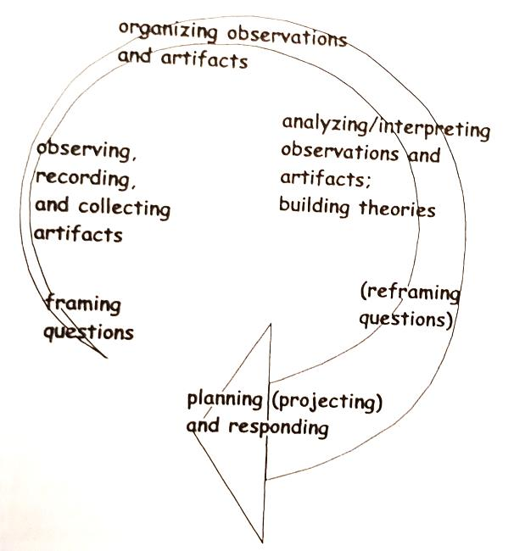

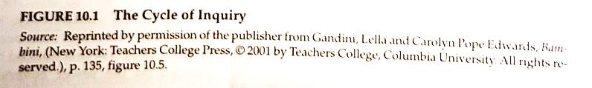

So, what will you implement AND how will you track your progress?
Do your own EXPERIMENT on teaching science:
    - What have you enjoyed learning about today?
    - What will you try better? Name one activity you’d like to try.
    - How will you implement it? What will it look like?
    - How will you record your progress?
    - When do you plan to review your results?

Feel free to ask any questions you might have to admin@drjoe.id.au
Thank you, very much, for your time today – Dr Joe

Science is generally considered a branch of philosophy, so in a sense, all scientific questions are philosophical questions about the workings of the natural world.

