Creating Science – Sherbet
To some scientists – taste and smell are essentially the same sense: chemoreception. And does our tongue really have different regions for sensing different tastes? Find out for yourself! #CreatingScienceSherbet

Suggested Outcomes
(NOTE: This is by no means an exhaustive list of possible outcomes, neither is it intended that ONLY these outcomes can or should be met. Science is a deeply interrelated activity, and you may find cross curriculum links you can and should use.)

Science understanding
- Biological sciences 5: Living things have structural features and adaptations that help them to survive in their environment

Science inquiry skills
- Planning and conducting F: Participate in guided investigations and make observations using the senses

Science as a human endeavour
- Nature and development of science 7: Scientific knowledge has changed peoples’ understanding of the world and is refined as new evidence becomes available

Science vocabulary words
Tier 1 (Everyday words) – food, sweet, sour, tasty, bitter, salty.
Tier 3 (Specialised vocabulary)
- Olfactory refers to smell.
- Gustatory refers to taste.
- Chemoreception refers to the human ability to detect various chemicals by direct contact, and includes both taste and smell.
- Umami is a base flavour popular in Asian foods, and kinda means ‘scrumptious’. It was ignored in Western science due to cultural ignorance amidst some 20th century European scientists, and we inherited that ignorance into Australia last century. But Umami is a taste strong plenty of Western foods, including parmesan cheese and soy sauce. It primarily detects the otherwise healthy glutamic acid, also produced as MSG (monosodium glutamate). “Since studies confirmed just a few years ago that our mouths contain taste receptors for this moreish savoury taste (the other four "basic tastes" had been widely accepted for, ooh, a few thousand years), so much in the history of recipes suddenly makes sense. Umami is why the Romans loved liquamen, the fermented anchovy sauce that they sloshed as liberally as we do ketchup today. It is key to the bone-warming joy of gravy made from good stock, meat juices and caramelised meat and veg.” (adapted 17 apr 2017 https://www.theguardian.com/lifeandstyle/wordofmouth/2013/apr/09/umami-fifth-taste)

Warning
- Taste will involve ingesting substances. Send a note home to check for any allergies, but be ready with a plan just in case.

Preparation
Note to families: Science next week and we’re exploring the mystery of chemoreception – taste and smell! We’re looking forward to seeing you all soon! Just a few things;
- We will be eating! The health labels are on the containers, but with sherbet there will be lots of sugar! In general, glucose in the form of icing sugar, citric acid and bicarbonate soda straight from the supermarket.
- We are using jelly crystals to flavour our sherbet. If you have something else to flavour sherbet (for health or curiosity reasons), you are welcomed to bring it along.
- We are going to doing some taste testing, so don’t give the answers away just yet! But please let us know if you or your students have any allergies to; 1.Apple Juice, 2.Tonic Water, 3.Lemon juice, 4. Salt water (regular table salt), 5. Sugar water, 6. Vinegar.
- Water to drink – to help clear the palate and protect from sugar clouds.
- Bring questions! What are you ready to learn about our sense of taste?

Taste and smell
- A blindfold
- Several food droppers of mysterious flavours, such as; Apple juice, Tonic water, Lemon juice (or vinegar), Salt water, Sugar water.
- Something to ‘clear the palate’, such as; Plain crackers, Water.

Tongue tests
- Q tips – lots and lots of cotton tipped sticks.
- 4+ water-based flavours;
  - 1 Tbsp sugar in a cup of water
  - 1 heaped tsp of salt in a cup of water
  - 1 cup of vinegar
  - Lemons – dripped directly onto the cotton tips.
And, if you can,
- Something flavoured Umami, such as soy sauce or anything with MSG (food additive code number 621. Some people are allergic to this flavour)
- Oil, to taste for fats.
- You will also need something to dry human tongues with – tissues tend to pull apart and get left behind, paper towel is better.
- A plan C just in case someone decides to throw up – however unlikely. Hard floors are a good idea and plenty of paper towels just in case. The sense of taste, and putting things in the mouth, is a very sensitive issue.
- To make sherbet you need ~1kilo icing sugar, 100g citric acid, 100g bicarbonate soda.

Suggestions for other year levels
As always, more material is presented here than can be used by the average class during the average lesson time. However, since the students’ questions can and should guide student learning, more material is presented for your convenience. Remember, it is not uncommon for students to only remember those points which answered their personal questions.

Younger:
Children at this age can have difficulty with focus. Avoid tangents if you’re attempting to make a key point.
You may want to gloss over or avoid the tongue map exercise.

Middle:
This activity is well suited to this age group.

Teen:
This group may have made sherbet before. They might prefer the critical thinking experiential exercise of the tongue map activity, or (after checking) experimenting with the recipe for sherbet.

Engage

Taste and smell – the relationship between taste and smell
How we actually recognise tastes has a lot to do with senses other than taste – can you believe it?! Sight, smell and touch are the main ones. Can you believe it’s actually quite difficult to recognise a flavour simply by flavour alone? Try this activity;
- Blindfold a volunteer.
- Feed them one taste test at a time.
- Have them try and guess what the flavour actually is.
Believe it or not, most of what we “taste” is actually being sensed by our olfactory system. In contrast to taste, where humans can only perceive five qualities (sour, bitter, sweet, salty, and umami), humans can smell thousands of odours.
SUGGESTION: It helps to have something to ‘clear the palate’ – that is, reset the taste buds back to normal (senses tend to remember what they’re sensing for a while; like how you can see an image you stare at in opposite colours? Or when you forget the strange smell in a room after you’ve been there for a while. Taste does the same too – when you brush your teeth with sweet toothpaste, it cuts out the sweet flavour of orange juice – many consider this an unwelcome experience!)

This can actually be helpful!
- Imagine you have to eat something you don’t like, like people do on reality TV some times. It’s natural to close your eyes, but did you know you can also block your nose to help you through the experience even more? Peas are quite palatable this way at times…
- Some people have poor eating habits. Can it be they might have under-developed sense of smell preventing them from enjoying the subtle flavours of many foods? The sense of smell improves with age, explaining the phenomenon of the ‘mature palate’ – see your doctor if you want an official test for taste discrimination.
- Some foods taste noticeably different – often more boring – when you’ve got the flu. This is often ascribed to the fact that a blocked nose can’t get many smells in, and you’re literally missing out of some of the flavours!

Explore
Tell students: just like plants and other animals, our body has various senses for detecting chemicals in our environment. We call that chemoreception, and two great examples are our senses of taste and smell.

Tongue tests
- Ask – does your tongue have different regions for detecting different flavours? Encourage discussion.
Activity: (read the entire following as a group before attempting the activity)
In groups of two, participant and scientist, try the following activity:
- Dip a cotton tip into one of the flavours you prepared earlier
- Dry off the participant’s tongue
- Touch the flavoured cotton tip to various parts of the participant’s tongue, and try to create a personalised map of where the flavours are: strong, weak, and non-existent.
- Try the five flavours (The debate’s still out on if we have a sixth – ‘fats’)
  - Sweet (sugar water)
  - Sour (vinegar or lemon juice)
  - Bitter (tonic water)
  - Salty (sodium in salt water)
  - Umami (soy sauce)
Tell students: most of our information about what we’re eating actually comes from the other senses, such as touch or taste.

Explain

The History of a scientific fable – a wildly simplistic review
(http://www.livescience.com/7113-tongue-map-tasteless-myth-debunked.html taken 17 apr 17)
- 1901 German scientist D.P. Hanig, unfamiliar with Asian food, concluded that sensitivity to the four tastes varied around the tongue, with sweet sensations peaking in the tip, etc.
- 1942, Edwin Boring, USA, also apparently unfamiliar with Japanese cuisine, took Hanig’s raw data and calculated real numbers for the levels of sensitivity. These numbers merely denoted relative sensitivities, but they were plotted on a graph in such a way that other scientists assumed areas of lower sensitivity were areas of no sensitivity. The modern tongue-map was born.
- 1974, a scientist named Virginia Collings re-examined Hanig’s work and agreed with his main point: There were variations in sensitivity to the four basic tastes around the tongue, but the variations were small and insignificant. Collings found that all tastes can be detected anywhere there are taste receptors—around the tongue, on the soft palate at back roof of the mouth, and even in the uvula, the flap that blocks food from the windpipe. Somehow, everyone ignores this.
- Today – what do you think? Is there some truth in tongue taste regions?

Why do we have smell and taste?
To help us survive!
  - Sweet: sugars are the most fundamental chemical for survival, giving us energy to move and live. In primitive times it was a great idea to eat loads of sugar when it came along, because it wouldn’t come along on its own very often – just with seasonal fruits and vegetables. Building up energy reserves from sugar was at times necessary to avoid starvation later on. (The same situation goes with fat).
  - Salty: Salts are absolutely vital for brain and muscle function, and do a lot to help the body stay healthy.
  - Sour: Sour flavours help to identify acids, such as the very important citric acid that helps us metabolise our food and fight infections. It is more popular with kids than adults, any suggestions why? Do growing kids need more vitamins than adults? However, a strong sour flavour that can also indicate a food is rotting, and must be avoided.
  - Bitter: Many dangerous chemicals are bitter, and this flavour can help us know if food is dangerous. Bitterness is the most sensitive of the tastes, and many perceive it as unpleasant, sharp, or disagreeable. Sometimes, however, it is desirable and intentionally added?!
  - Umami: Umami is a ‘yummy’ taste and is described as savoury or meaty. It can be tasted in parmesan cheese and soy sauce, and is also found in many other fermented and aged foods. It helps good food taste delicious, but is now overused in many contexts. It helps signal the presence of proteins, which are vital to survival, and helps to actually make proteins that we need. Our body can even synthesize it. Interestingly, human breast milk contains one of the highest rates of MSG of all mammalian milks – helping to explain the importance of the taste in humans.
Of course, now we can remove tasty chemicals from their context entirely, making food made entirely out of taste and without any useful nutrients – colloquially called ‘junk food’. But our bodies still fight to keep the energy as long as possible, making us often quite overweight and unhealthy!
Our sense of chemical reception used to be pretty good at helping us deal with the natural world, but with a whole load of artificial chemicals in our food now, it’s wise to read product labels!
These are only a few tastes; do you think there might be more? Astringent and pungent are often considered to be a simple mix of other flavours. And just like different colours can create completely different light, when flavours get together, especially with our sense of smell, it can be impossible to name the billions of combinations! Where do the following tastes arise?
- Heat (chilli peppers) touch receptors, not taste
- Cool (peppermint) touch not taste
- Numbness
- Metallicness
- Calcium “Chalky” – present in the intestinal tract and brain, but not tongue??
- Starchiness
- And yet there may be many more!

Elaborate
- Ask students if they can design new ways to test this explanation, is it really sufficient? Can they think of further or better explanations, and the experiments needed to test them?

Super sensors
Some people are lucky enough to have a hundred times the normal receptors for taste or smell – they’re super sensors. Do some research and find out how you can discover if you’re a super sensor.

Did you know?
The body has detectors for chemoreception, known as chemoreceptors, on the INSIDE as well? Peripheral chemoreceptors can be found in the aorta (the big artery leaving the heart), which detects changes in blood oxygen and carbon dioxide, but not pH, and at a point in the carotid artery (in the throat) which detects all three.

Fooling taste
Did you know there are simple chemicals that can fool your sense of taste?
- Peppermint (menthol to be precise) sets off the cold and hot receptors.
- Capsicum (capsaicin to be precise) sets off hot and pain receptors.

Make sherbet
Just for fun (see our book Creating Science).

Evaluate
- Review with students what they felt they learnt from this lesson. Did they have any questions at the start that they feel were answered?

Success criteria
- Review the Learning Intentions of this lesson with students. Was it met?
At the end of each class, review the learning objective and see how we did. Ask:
- Did you achieve your learning goal?
- What did you learn?
- What worked to help you achieve it?
- What might you do better next time?
- (If needed) where can you go for extra help or information?

Assessment

Prior Learning:
Ask:
- What is taste? How does out body ‘taste’ things?
- Are taste and smell different? How? And in what ways are they the same?
- How can we find out if our tongue has certain taste regions?

Formative:
As students are learning, help them self-monitor their own learning and achievements. Ask:
- Do you think the ‘standard’ answer in science is a correct map of your tongue?
- Are we thinking safely enough? How can we stop the spread of germs in this activity?

Summative:
Help students consider ways they can communicate their new understanding to others, just as scientists need to do. Perhaps they can put up and present diagrams of their own tongue maps, and explain the 5 basic human tastes.

So what?
Taste and smell are essentially the same sense – chemoreception. We even have chemoreceptors inside our blood vessels.
The taste map is WRONG – and we can make our own and discuss it.
Taste not only helps us like foods we need, it can keep us safe from foods that are bad for us.

Creating science

Science understanding
As we made our tongue map, we learned that;
- Biological sciences 5: Living things have structural features and adaptations that help them to survive in their environment

Science inquiry skills
When exploring ways to accurately measure taste, we explored that;
- Planning and conducting F: Participate in guided investigations and make observations using the senses

Science as a human endeavour
As we realised our individual tongue maps differed from the ‘standard’ answer, we saw that;
- Nature and development of science 7: Scientific knowledge has changed peoples’ understanding of the world and is refined as new evidence becomes available (ACSHE119)

Tips from the Masters – making sherbet

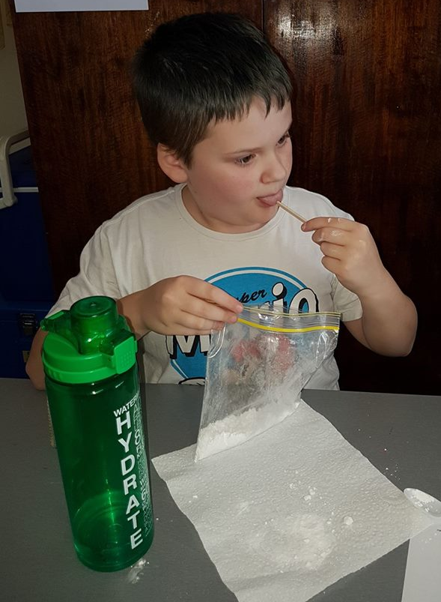
Only use LITTLE doses of sherbet, and have a drink on hand for powdery emergencies!

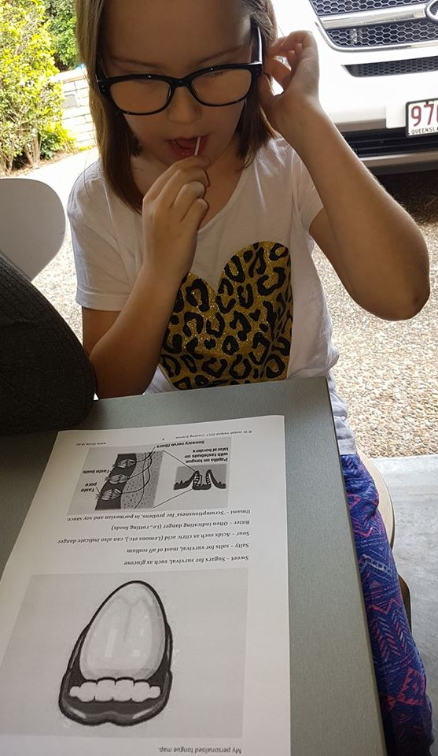
Carefully measure – do you think the standard tongue map is accurate in your case?

Why do we have a sense of taste?
To help us survive!

Sweet: sugars are the most fundamental chemical for survival, giving us energy to move and live. In primitive times it was a great idea to eat loads of sugar when it came along, because it wouldn’t come along on its own very often – just with seasonal fruits and vegetables. Building up energy reserves from sugar was at times necessary to avoid starvation later on. (The same situation goes with fat).
Salty: Salts are absolutely vital for brain and muscle function, and do a lot to help the body stay healthy.
Sour: Sour flavours help to identify acids, such as the very important citric acid that helps us metabolise our food and fight infections. It is more popular with kids than adults, any suggestions why? Do growing kids need more vitamins than adults? However, a strong sour flavour that can also indicate a food is rotting, and must be avoided.
Bitter: Many dangerous chemicals are bitter, and this flavour can help us know if food is dangerous. Bitterness is the most sensitive of the tastes, and many perceive it as unpleasant, sharp, or disagreeable. Sometimes, however, it is desirable and intentionally added?!
Umami: Umami is a ‘yummy’ taste and is described as savoury or meaty. It can be tasted in parmesan cheese and soy sauce, and is also found in many other fermented and aged foods. It helps good food taste delicious, but is now overused in many contexts. It helps signal the presence of proteins, which are vital to survival, and helps to actually make proteins that we need. Our body can even synthesize it. Interestingly, human breast milk contains one of the highest rates of MSG of all mammalian milks – helping to explain the importance of the taste in humans.
Of course, now we can remove tasty chemicals from their context entirely, making food made entirely out of taste and without any useful nutrients – colloquially called ‘junk food’. But our bodies still fight to keep the energy as long as possible, making us often quite overweight and unhealthy!

Appendix: the Tongue Map
Is it: 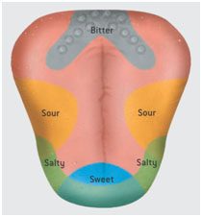

Or 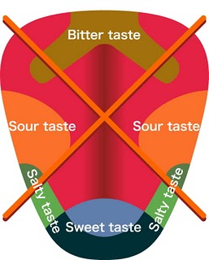

Lies, all lies! http://www.livescience.com/7113-tongue-map-tasteless-myth-debunked.html

Student handout – my personal tongue map:
Draw a picture of your personalised tongue map, based on your research of testing chemicals
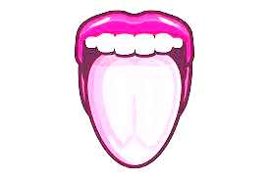
Sweet – Sugars for survival, such as glucose
Salty – Salts for survival, most of all sodium
Sour – Acids such as citric acid (lemons etc.), can also indicate danger
Bitter – Often indicating danger (i.e., rotting foods)
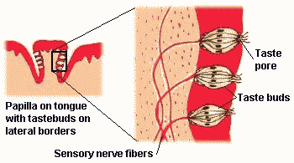
Umami – ‘Scrumptiousness’ for protiens, in parmesian and soy sauce.

