Creating Science –Pendulums.
Pendulum’s rock! Back and forward, back and forwards.

Suggested outcomes
(NOTE: This is by no means an exhaustive list of possible outcomes, neither is it intended that ONLY these outcomes can or should be met. Science is a deeply interrelated activity, and you may find cross curriculum links you can and should use.)
Physical sciences 2: A push or a pull affects how an object moves or changes shape (ACSSU033)
And Science Inquiry Skills, particularly, Questioning and predicting 2: Pose and respond to questions, and make predictions about familiar objects and events (ACSIS037)
And
Physical sciences4: Forces can be exerted by one object on another through direct contact or from a distance (ACSSU076)
And Science Inquiry Skills, particularly Planning and conducting 4: With guidance, plan and conduct scientific investigations to find answers to questions, considering the safe use of appropriate materials and equipment (ACSIS065)

Warning
- Pendulums and bobs can be extremely heavy and very dangerous if thrown around.
- Long strings with heavy weights make surprisingly effective weapons. Please exercise all maturity and adult caution.

Preparation
- Bring a pendulum clock of similar device, if you can.
- A pendulum for every class member, or two, with various lengths and weights. If you can’t get professional pendulums, a weight (such as a balloon filled with half a cup of sand) tied with a string to a hand rail might work. Don’t tie them to the roof, it is too high and dangerous.

Suggestions for other year levels
As always, more material is presented here than can be used by the average class during the average lesson time. However, since the students questions can and should guide student learning, more material is presented for you convenience. Remember, it is not uncommon for students to only remember those points which answered their personal questions.

Younger:
This activity is challenging for this age group, but the main outcome, that of isochronism is possible.

Middle:
Some basic maths may be introduced at this age level, such as cycles per second to test for accuracy.

Teen:
The complexity of pendulum calculations may begin to be appreciated at this age, as will the technical difficulties of developing accurate timing devices. Such should be appreciated, if not achieved.

Engage
- Practice scientific thinking using returning roller. Point out
  - Asking science questions.
  - Testing answers with science.

Explore
- Explain briefly the history of the pendulum, at the end of this document.

- Cull the question list to help students to generate a testable scientific question.

- Give students the handout ‘question quest’ and invite students to explore and play with the pendulums. You might like to challenge them to find out:
  - Does a bigger swing move any faster than a smaller one?
  - Is a heavy bob slower or faster than a light one?
  - Is a long pendulum slower or faster than a short one?
Advanced
- Try measuring your pendulum in order to create exact theories or scientific laws.

Explain
- Help students to use scientific testing to answer their questions. Reward them for each of their own questions that they write up, and answer.

How does a pendulum work?
Taken 2 feb 2017 from http://www.explainthatstuff.com/how-pendulum-clocks-work.html
A pendulum works by converting energy back and forth, a bit like a rollercoaster ride. When the bob is highest (furthest from the ground), it has maximum stored energy (potential energy). As it accelerates down toward its lowest point (its midpoint, nearest the ground), this potential energy is converted into kinetic energy (energy of movement) and then, as the bob climbs up again, back to potential energy. So as the bob swings (oscillates) back and forth, it repeatedly switches its energy back and forth between potential and kinetic. Something that works this way is called a harmonic oscillator and its movement is an example of simple harmonic motion, though we won't go into those things here.
If there were no friction or drag (air resistance), a pendulum would keep on moving forever. In reality, each swing sees friction and drag steal a bit more energy from the pendulum and it gradually comes to a halt. But even as it slows down, it keeps time. It doesn't climb as far, but it covers the shorter distance more slowly—so it actually takes exactly the same time to swing. This handy ability (technically called isochronism, which just means "equal amounts of time") is what makes a pendulum so useful for timekeeping.
Galileo figured that out straight away and though he never actually managed to build a complete pendulum clock. He came quite close (here's a model of the 1642 pendulum clock he was designing just before his death); it was left to another brilliant scientist, Dutchman Christiaan Huygens (1629–1695), to finish the job in the 1650s. (Read more about Huygens and his clocks and see a photo of the first Huygens pendulum clock of 1656.)
Artwork: A pendulum is constantly swapping potential energy and kinetic energy.

Elaborate

Anatomy of a Pendulum
Now it is time to learn the correct names for the parts of a pendulum. The weight at the bottom is called the bob. The place where it hangs is usually referred to as the pivot and the string is called the rod. When the pendulum is hanging straight down and not moving at all, it is said to be at its equilibrium point. Once the pendulum starts to move, there are names for the aspects of its movement.
The size of a swing is called the amplitude. The amplitude is measured in degrees--the same degrees that you use to measure angles in geometry. One complete swing back and forth is called a cycle. The time it takes for a pendulum to complete one cycle (a complete swing) is called its period (meaning the period of time it takes). And just to confuse you, the number of cycles (swings) per second (or per minute) is called the frequency.
(http://www.ellenjmchenry.com/homeschool-freedownloads/energymachines-games/documents/PendulumMotionPhysicsLab.pdf taken 2 feb 2017)
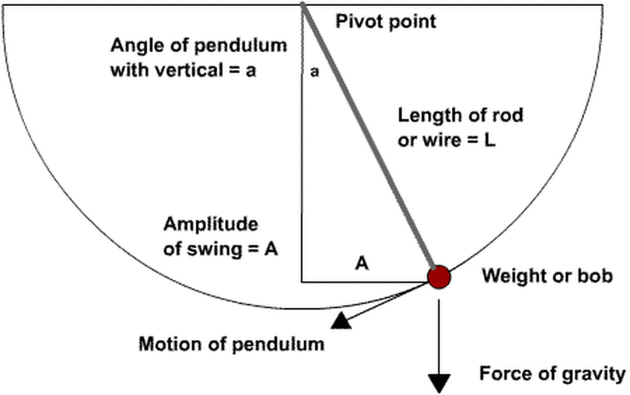

Timing games
A few simple games can be attempted:
- Can you make two pendulums perfectly in time?
- Can you make a short, heavy bob go at the same speed as a lighter, longer one?
- Can you get a bob to go at exactly once per second?
- What if you put a weight half way up the rod of another pendulum? (welcome to chaos) This is called a compound pendulum.
How scientists ever become so excited about a pendulums potential for accuracy I’ll never know!

ETC
Did you know you can use pendulums to (see appendix):
- Make pretty and intricate patterns with sand or ink?
- Detect earthquakes from far away? See Zhang Heng's seismometer from 1st century BC.
- Measure the turning of the earth? See Foucault Pendulum from 1851.
- Make some fun toys like neutons cradle?

Accuracy
What else can affect the accuracy of a pendulum clock? (from Wikipedia)
  - Pendulums are affected by changes in gravitational acceleration, which varies by as much as 0.5% at different locations on Earth, so precision pendulum clocks have to be recalibrated after a move. Even moving a pendulum clock to the top of a tall building can cause it to lose measurable time from the reduction in gravity.
  - Fat pendulums cause air resistance, which while it does not meaningfully effect timing, makes the pendulum swing less far and eventually stop.
  - Pendulums drag along a little air with them as they swing, increasing their momentum, thus slowing the clock down.
  - By displacing the air, the pendulum actually weighs less than it would in a vacuum, slowing it down. This depends on the air pressure, and the volume and density of the pendulum, but not its shape!
So all pendulum clocks will eventually slow down. How do we keep them moving? With a teeny, tiny push at the lowest point of their swing.
  - In 1826 British astronomer George Airy proved what clockmakers had known for centuries; that the disturbing effect of a drive force on the period of a pendulum is smallest if given as a short impulse as the pendulum passes through its bottom equilibrium position.[2] Specifically, he proved that if a pendulum is driven by an impulse that is symmetrical about its bottom equilibrium position, the pendulum's period will be unaffected by changes in the drive force.[100] The most accurate escapements, such as the deadbeat, approximately satisfy this condition.[101] (Wikipedia, 2 feb 2017)

Advanced group forces
What forces are working on the pendulum? Only two:
- Gravity, and it always points downwards at the same amount all the time = 9.8 m/s2 (here on the surface of earth, that is)
- Acceleration – the pull of the string on the bob to stop it flying away.
So why does it swing? Inertia. The gravity pulls it down, but the string turns that motion into a swing. The bob moves through the equilibrium point, where gravity begins to slow it down again, until it stops swinging up, and then back it goes! Once it returns to its starting point, we have a cycle.

Evaluate

Diagnostic:
Ask students the question: How important are questions to science?
Ask students: How do scientists know when they have an idea that works?

Formative:
Help students to develop testable questions.

Summative:
Help students consider ways they can communicate their new understanding to others, just as scientists need to do.
Have students present an oral presentation to a board of educated peers, just like real scientists might occasionally do, to present their knowledge. Be sure to involve these simplified steps of the national curriculum;
- What was their testable question (i.e., what did they want to find out)?
- How did they develop and enact a test, including their prediction?
- How did they gather data and conclude on the results of their test?

Creating science
A discussion of forces, including gravity and possibly momentum. A discussion of the properties of matter, in particular inertia. (Physical sciences4: Forces can be exerted by one object on another through direct contact or from a distance (ACSSU076))
Science Inquiry Skills, particularly Questioning, Planning and conducting. Discovering useful information about pendulums and seeing how those ideas recreated by students are ACTUALLY used by REAL scientists and technologist to make clocks.

Appendix

The history of the Pendulum
From http://www.ellenjmchenry.com/homeschool-freedownloads/energymachines-games/documents/PendulumMotionPhysicsLab.pdf
PENDULUM MOTION People have been using pendulums for thousands of years. Children have been swinging on ropes and vines since ancient times. Some ancient cultures figured out how to rig up baby swings. The Egyptians invented an irrigation device made of a bucket hanging from a beam. Weapons such as slings and trebuchets used swinging objects. During the Renaissance, heavy pendulums were used as sources of power for machines such as saws and pumps.
You’d think that over the millennia someone would have noticed how incredibly regular the motion of a pendulum is, and thought of using them for keeping time. But the first written record we have of this discovery is by Galileo, in the year 1602--not that long ago when you consider the entire history of the human race. The story goes that one day Galileo was sitting in the cathedral of Pisa (the town in Italy that has the famous Leaning Tower). His mind was restless and he turned his gaze toward a chandelier above his head. For some unknown reason, the chandelier was swinging back and forth just a bit. (Perhaps it was a hot day and the doors had been opened to allow air to circulate.)
As Galileo watched the motion of the chandelier, he noticed that the swinging motion was very regular. If we had been sitting there, we might have said the swings were like the ticking of a clock. But Galileo would not have thought this. His everyday life had no ticking clocks in it. Clocks did exist, but they were large and expensive. A town might have one clock, placed on the front of a public building so everyone could see it. Many people still used sundials or water clocks. Portable time devices, such as pocket watches, would not exist for another two hundred years. (Even large grandfather clocks were well after Galileo’s time.) As Galileo watched that chandelier swing back and forth, he began to wonder if the time of each swing would decrease as the chandelier began to slow down. He wished he had a way to time each swing. Then a brilliant thought crossed his mind--he did have a portable timing device he could use! As long as he sat still, his pulse was very regular. He put his finger on his wrist and began to count the time of each swing, using pulse beats as his unit of measure. What he discovered surprised him. The time of the swings stayed the same, even when the swings got very, very small.
This was perhaps not the result he had expected. It seemed natural to assume that the short swings would take less time since they were shorter. But no--the time of each swing was identical, no matter how long or short the distance traveled. You’d think that Galileo would have rushed home and started experimenting with pendulums immediately, realizing that he was on the brink of a major scientific discovery. But he didn’t. Perhaps he did a few experiments, but he was a busy college student at this time and did not have enough time to do a thorough investigation of them. It was not until several years later, in 1602, that Galileo was able to do enough research to be able to state with certainty the basic principles of pendulum motion.

Question Quest
What would you like to know about the Pendulum?

Appendix: Motivational poster - Science and messing about

Appendix: Art with pendulums
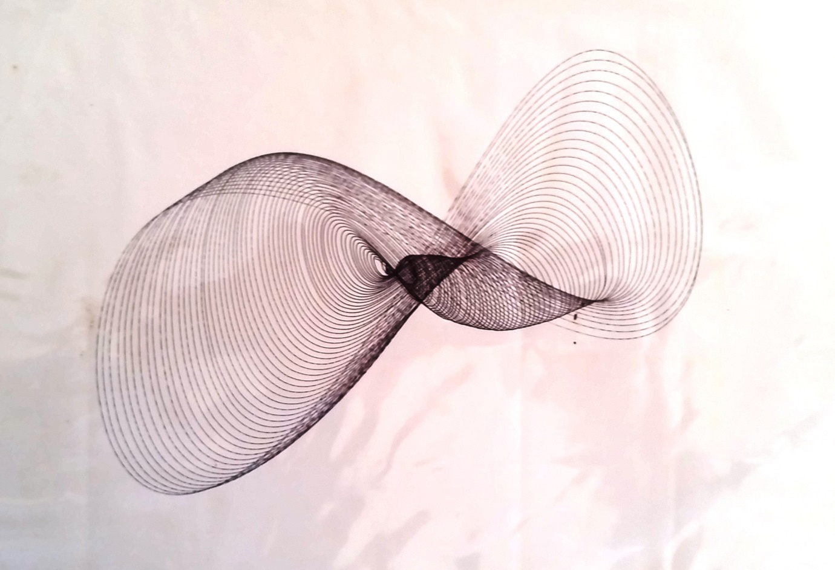
This beautiful image was made in the 1980’s at the science centre in Canberra, Australia.
It uses a ball point pen suspended carefully from a very heavy pendulum. As friction between the pen and the paper slow the pendulum down it helps to create these wonderful patterns, spiralling in to rest.

Appendix: Detecting earthquakes with pendulums.
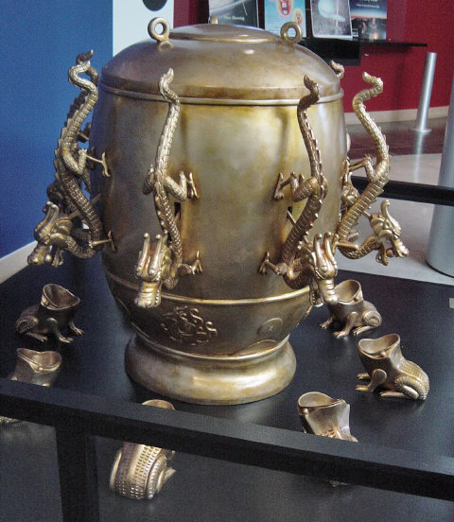
Zhang Heng's seismoscope from 1st century BC. A heavy pendulum inside was set swinging and when an earthquake happened it would push a little ball down a ramp, which was used to indicate the direction of the earthquake with mild accuracy.

Taken 5 feb 17 from By en:user: Kowloonese - en:File:EastHanSeismograph.JPG, CC BY-SA 3.0, https://commons.wikimedia.org/w/index.php?curid=87690

Appendix: Toys with pendulums
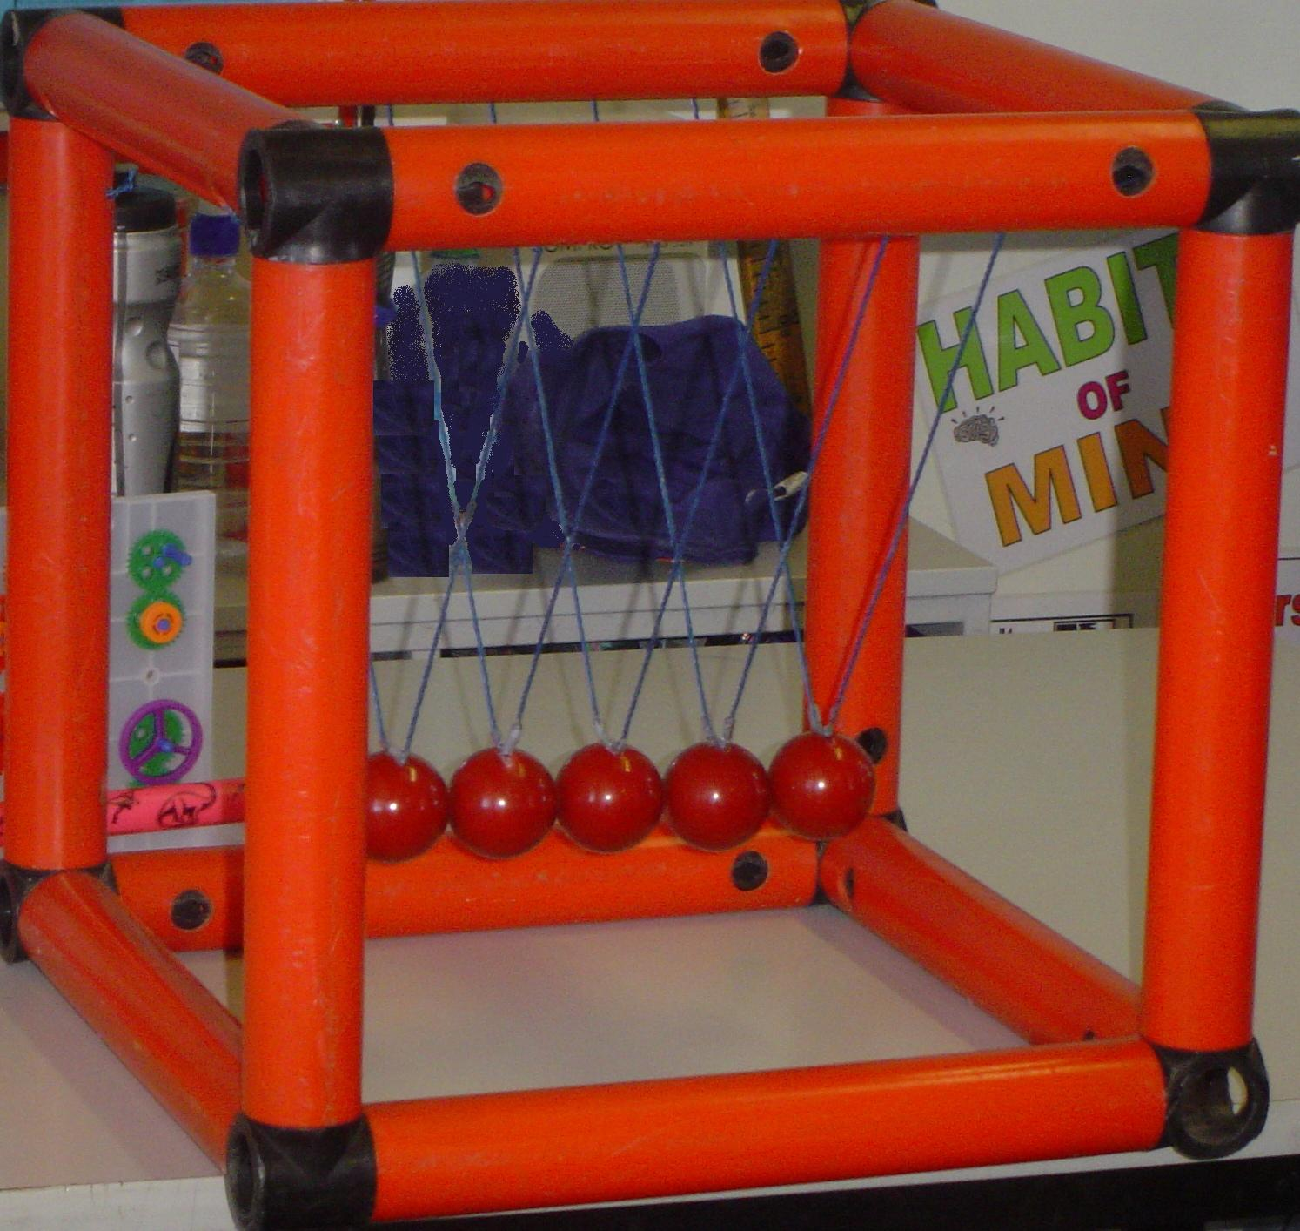
A Newton’s Cradle.
Named in Honour of Sir Isaac Newton (but not invented by him) this toy illustrates pendulum motion and all of Isaac’s laws of motion and gravity. He certainly never slept in this ‘cradle’ either.

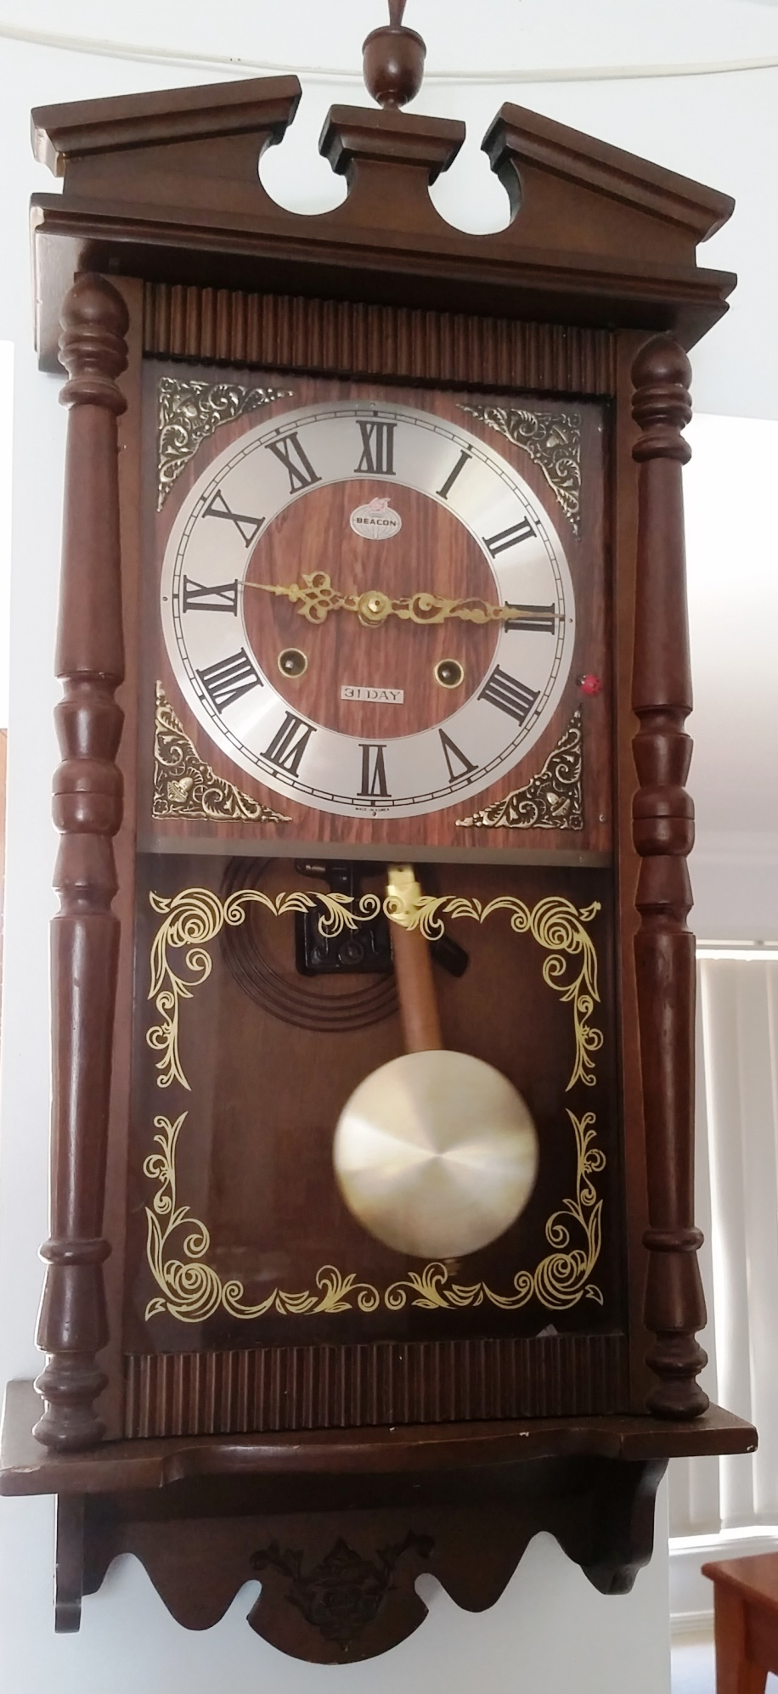
Appendix: Time with pendulums

Here we see, proudly displayed, the analogue pendulum clock given to Dr Joe by his parents. It was originally made in Indonesia.

Appendix: measuring planetary motion with pendulums
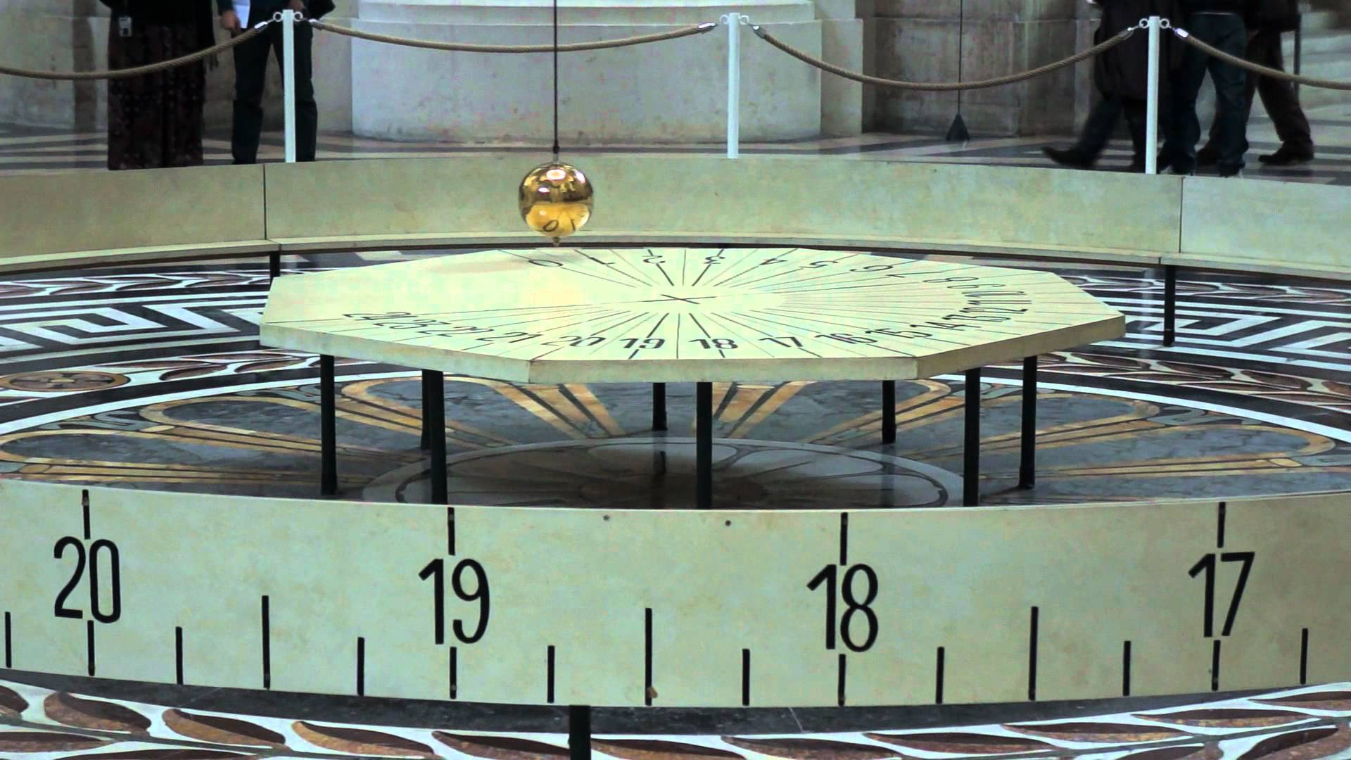
Taken 6 feb 17 from https://www.google.com.au/search?q=paris+pendulum&safe=active&rlz=1C1CHBF_en-GBAU711AU711&source=lnms&tbm=isch&sa=X&ved=0ahUKEwjJ3LDziPrRAhVDrJQKHbmwDugQ_AUICCgB&biw=1517&bih=751#imgrc=LszZfvFoUGRXvM:

The Paris pendulum.
As the world turns through night and day, the pendulum keeps swinging in the same direction. This means the world turns under the pendulum, making it seem as though the pendulum points to different points of the clock over the course of the day.

