Creating Science – Moon in Space.
Earth’s nearest companion and oldest friend, what science secrets do you hold Mr Moon?

Suggested outcomes
(NOTE: This is by no means an exhaustive list of possible outcomes, neither is it intended that ONLY these outcomes can or should be met. Science is a deeply interrelated activity; all outcomes at all leaves, when appropriate, should be integrated.)
Earth and Space Science
Y3 - Earth’s rotation on its axis causes regular changes, including night and day
Y5 - The Earth is part of a system of planets orbiting around a star (the sun)

Also
Science as a human endeavour (9-10) Scientific understanding, including models and theories, are contestable and are refined over time through a process of review by the scientific community.
Science as a human endeavour (9-10) Advances in scientific understanding often rely on developments in technology and technological advances are often linked to scientific discoveries

Warning
- Paint, drawing implements, and small balls. Be wise.

Preparation
- Prepare your own model of the earth and moon before you begin. Make sure you have a representation of the two sides of the moon – the near and the far side.
Looking forward to seeing you all soon. If you’d like, bring an inflatable earth or rubber ball to move around. We’re visiting the Moon!

Suggestions for other year levels
As always, more material is presented here than can be used by the average class during the average lesson time. However, since the students questions can and should guide student learning, more material is presented for you convenience. Remember, it is not uncommon for students to only remember those points which answered their personal questions.

Younger:
This activity is well suited to this age group.

Middle:
Simple extensions are easy to incorporate in this activity including;
- Drawing out a monthly map of the moon cycles. Pick the same time each day and draw the moon. You will learn the moon does, indeed, come out during the day. Also, that the whole moon is there all the time, we just can only see the part that has light shining on it.

Teen:
Complex extensions include;
- Mathematically comparing tides to moon position. Does the moon really help to cause the tide? Prepare a table of both measurements over several weeks and compare positions (or be truly devout and use regression analysis)
- Calculate the gravitational pull of the sun on both the earth and the moon, and compare these with the gravitational pull of the earth on the moon. Which has the greatest gravitational pull on the moon – the sun, or the earth? The answer may surprise you. Some scientists think we should not call the moon, Earth’s moon, because it’s really just a binary planetary system caught up in each other’s gravity and both orbiting the sun. what do you think?

Learning Intent (student friendly)
'We are learning to' (WALT): demonstrate how the sun, moon and earth move relative to each other.

Success criteria
'What I'm looking for' (WILF): How to show day and night, eclipses, seasons and a year

Student learning goals
Help students make a self-monitored learning goal for this lesson.

Evidence of learning
How will you know when the learning goal is achieved? What EVIDENCE do you have that your students have met or exceeded the learning expectations?

Ideas for monitoring
Can student demonstrate the tidally locked motion of the moon relative to the earth – it always points towards the earth.

Engage
- Make sure all students write down any questions they may have generated during this phase regarding the topic for today.
Bring in some pictures, paper cut out, or 3d models of the moon. Allow students to discuss the objects, and write down any questions they may have. You might want to engage them in a KWL activity.
- Ask students what they already KNOW about the topic of the moon. Write it down as a group, or have them draw pictures of their knowledge and ideas.
- Brainstorm, as a group, the things the students WANT TO KNOW about the moon – that is, write or draw any questions they may have. Remember as a brain storm it’s not important to answer those questions yet, and there are no stupid questions when creativity is the goal! After the brainstorm, you can then cull the list of questions with a focus on the kinds of questions that science can help with.
- At the end of the unit, write, or draw, what you have LEARNED about the topic. What was news to each of the students? Were they surprised to know the moon does come out during the day? Did they gasp at the realisation that the moon turns around so that it is always facing the Earth?
Being prepared to write down what they have learnt helps students to focus on their own learning, and is thus a metacognitive strategy that can help them learn how to learn, and be better prepared to structure their own learning goals in the future.

Explore
- Encourage and validate student explanations of this phenomenon. You may like to ask students to write or draw their explanation personally to avoid embarrassment to students unfamiliar with this material. Remember, ‘I don’t know’ is a valid explanation in science – it is the beginning of learning new things!

Try to set up and demonstrate the movement of the moon around the earth.
You can find some good videos’ online, or do so by having one student hold a model Earth, and having them demonstrate how the moon moves around it – however, the very tricky part is having the student with the moon make sure they face the same side of the moon towards the Earth at all times. Invariably the moon student, or the moon model itself, will have to turn around in order to go around the earth AND keep the same side of the moon always pointing at the Earth.

Explain
The Earth is in space, floating along because floating along is what things do unless something pushes or pulls them. The earth goes around the sun, this make up a year. And, of course, the earth rotates around, and this is what makes up the days.
Meanwhile, the moon goes around the Earth, and this helps to make up the months. (Since it takes about 28 days for the moon phases to repeat).
The moon is made of rocks, and is very far away.
1/ The Moon turns around on its axis just like earth does, and so the moon has days as well. However, its day is a bit longer than Earth and, because of gravity, happens to be almost exactly the same length as it takes for the moon to go around the Earth. This means that one side of the moon – the same side at all times – is facing towards Earth.
We can say the moon has ‘two sides’.
The “near side” of the moon is the side always facing the Earth.
The “far side” of the moon never faces towards the Earth, but we know what’s there because we’ve sent spaceships and satellites to find out. We used to call the far side the dark side, but that was a terrible mistake, because it’s no darker than any other part of the moon, the far side has day and night just like the near side.
The “far side” of the moon has many craters, because it’s been hit by loads of asteroids over its long history (4.5 billion years or so). We’re kind of lucky, as a planet, that we have such a nice, big, moon nearby. There’s a good chance it has helped to protect the Earth from some dangerous asteroids by taking the beating itself.
Earth has lots of natural weathering processes, such as wind and rain, to help cover up the craters over the centuries. However, the moon has practically no atmosphere, so there’s no wind or rain. So the craters can last millennia, even millions of years until new meteorite impacts cover up the old ones.
The “near side” of the moon has been hit by just as many asteroids over time of course. However, the moon long ago, like earth now, had a liquid mantle. Lava once flowed on its surface, covering up many of the earliest meteorite impacts. These long ago cooled down to form wide plateaus of solid stone. Oddly, these long plateaus were called ‘seas’ (or ‘mar’) by the first man of our culture to look at them through a microscope (Galileo from Italy, incidentally). The name has stuck, of course, but there aren’t any water seas on the Moon!
So why are there only mar on the near side, and not on the far side of the moon? See next section:
(Don’t make the mistake of calling the far side the ‘dark side’. It’s inaccurate and confusing – but that’s language for you.)

Elaborate
The answer is gravity.
As you can see from the section in Creating Science on forces, all forces are in pairs.
So the Earth is pulling on the moon, otherwise it would fly away into space. Thus the moon is pulling on the earth, that’s what causes the tides. But the Earth’s pull on the moon gives it some tides as well. Now rock does not move very much, but long ago, when liquid magma poured under the surface of the moon, it was pulled in the direction of the Earth. Thus the near side of the moon has wide, volcanic plateaus we call ‘seas’, and the far side does not.
- Ask students if they can design new ways to test this explanation, is it really sufficient? Can they think of further or better explanations, and the experiments needed to test them?
Gravity also explains why the Moon is always facing the Earth. The tug of the Earth on the moon slowed it down till it faced us all the time. In the same way, the tides caused by the moon are slowing the Earth down as well, till in a few million years the average day will be 25 hours long. Fascinating!
- Allow students to play with and explore the moon moving around the Earth model. What effect would certain changes have?

Debunking Moon Myths.
Make an event, or plan a project, around proving (or disproving) some famous moon myths. This is a great way to experience scientific knowledge as requiring argument and evidence, not just belief in expert opinion.
- The moon is made of cheese – this is a lie we tell to little kids to amuse ourselves. Scientists have travelled to the moon, and you know what they found? Rocks, pretty much the same kids as we have here on earth.
- The moon landing was a conspiracy – the thing about a good conspiracy is that it never goes away. Any evidence for the conspiracy theory is taken as support of the theory, and any evidence against the conspiracy theory is taken as support for the conspiracy. So it is a lot harder to disprove a conspiracy theory. However, some very solid science has gone behind the debunking of the moon myth. You’ll still have more luck convincing some people the earth really is flat.

Gravity and the moon.
There are other examples in the universe where gravity not only causes an object to revolve (as in a planet around a sun), but where it also causes changes in revolution. Mercury is a good example, locked into a 3/2 motion around the sun. Can you think of any other examples from our solar system and beyond?

Evaluate

Diagnostic:
A focus on what students didn’t know at the start of the unit is not important for their final results – it’s only to help you as a teacher know what to teach, and to help you choose what experiences are most important for them to learn from.
Finding out what they need to learn about is one of the most important things that diagnostic evaluation is all about. The “KNOW” part of KWL above is a step in this direction.

Formative:
Listening to students discussions during the activity, and observing how they move the Earth and Moon models, is also helpful.

Summative:
Have students present a model of the moon, with the ‘near’ and ‘far’ sides purposefully illustrated with craters and mar. You can have them demonstrate the relative motion as well, remember, the moon goes around the earth about 12 times in a year.
Encourage older students to engage in the debate about moon conspiracies. This helps hone their reasoning and argumentation skills, as well as their scientific literacy and appreciation for what it takes to create scientific knowledge.

Creating science
The earth, sun, and moon all move to create night, day, seasons and phases of the moon.

Appendix.
The ‘far’ side of the moon – note lots of craters
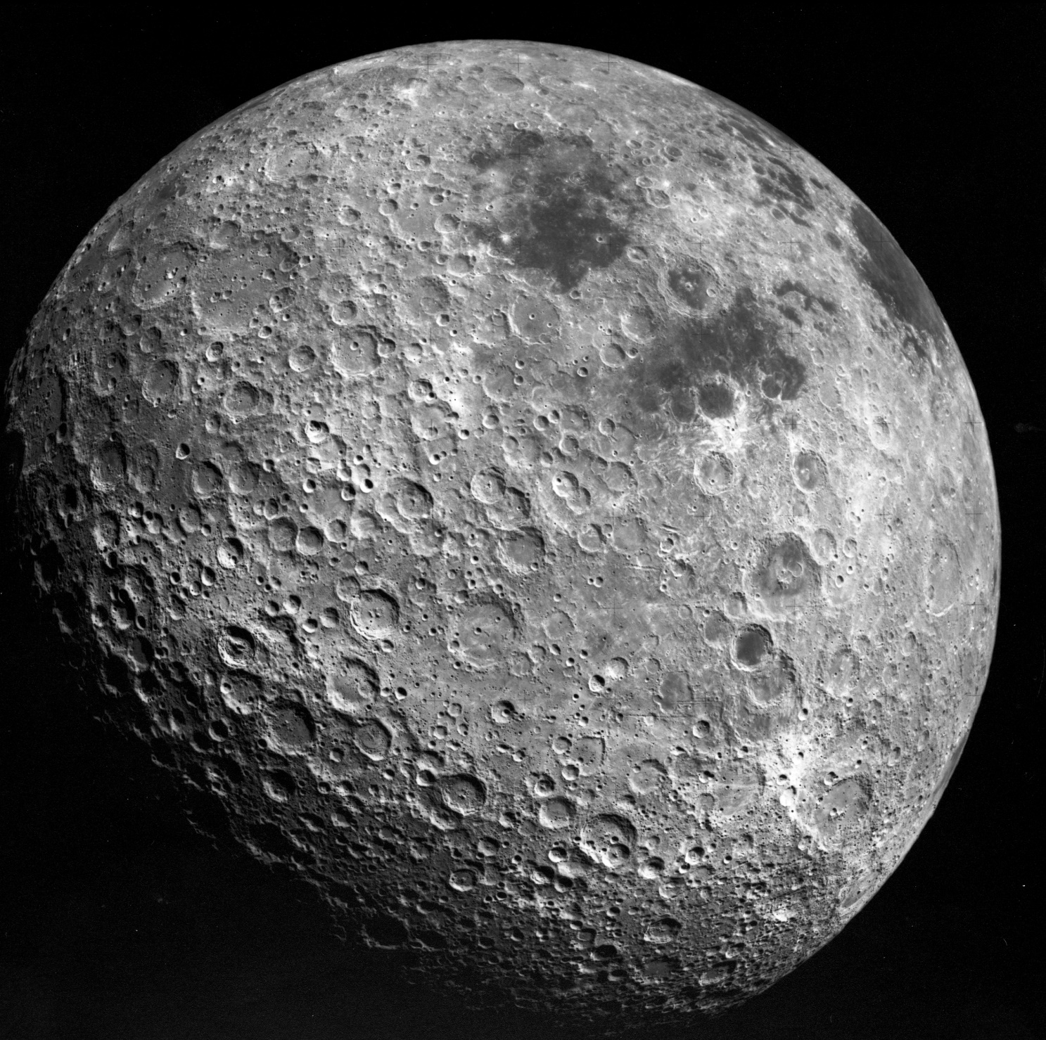

The ‘near’ side of the moon. Note: lots of ‘seas’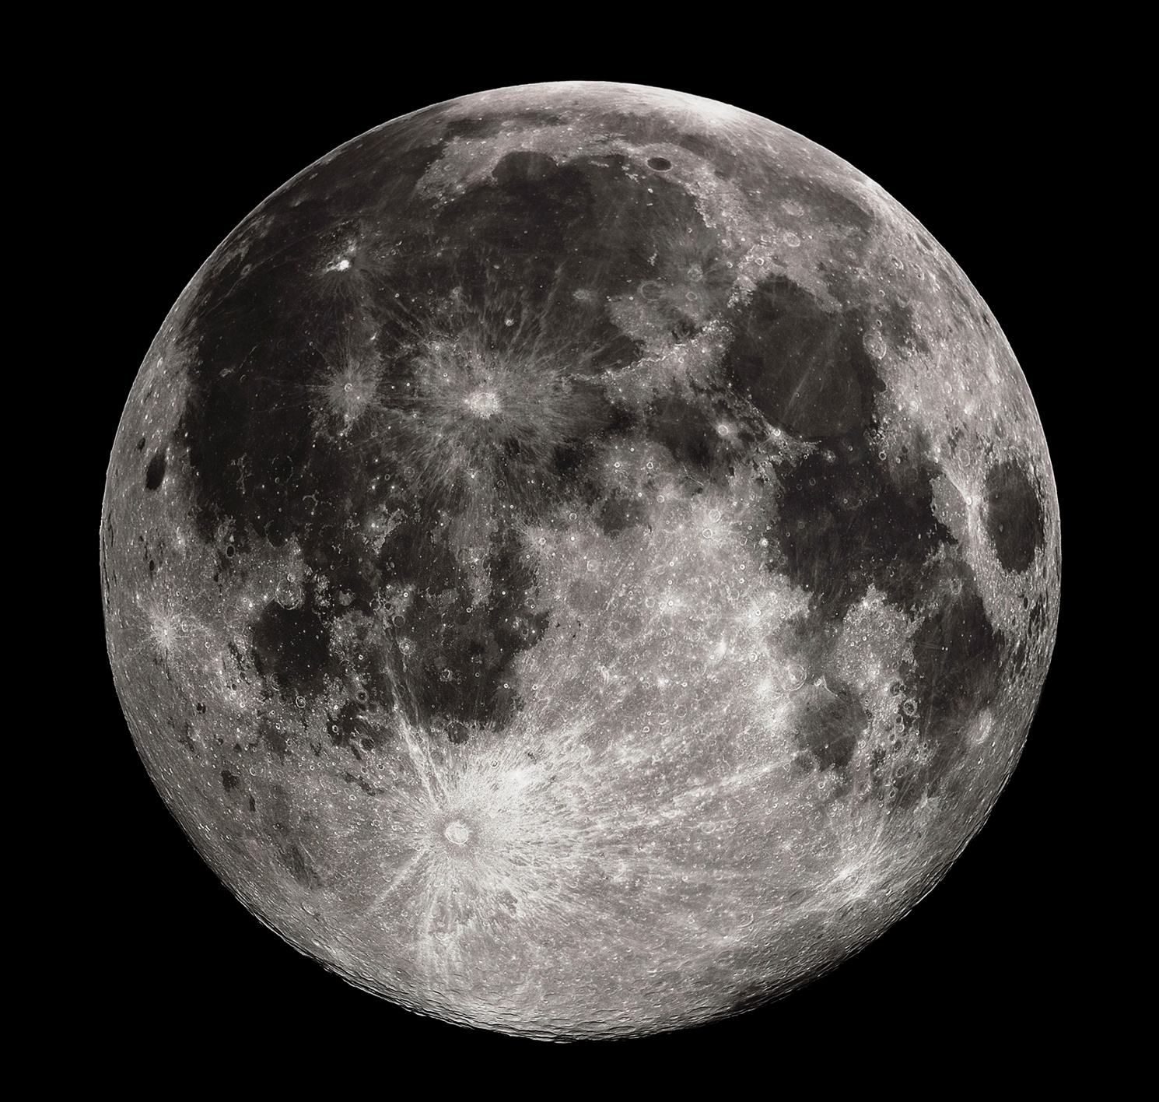

Why? Because gravity – the earth’s pull on the moon creates a kind of tide which has locked the moon into looking at us all the time. On the other hand, the moon’s gravity causes tides on earth, which is slowing the earth down about 2.3 milliseconds per century since the 8th century BC. In the far distant future, Earth will be stuck looking at the moon well – and the moon will not seem to move from its point in the sky at all.
Certain well-meaning science fiction movies have caught on to this idea, and perpetuate the myth that the moon has a dark side we have difficulty seeing. Truth is it’s just as difficult as seeing any other part of the moon, we just can’t see it from Earth, and it’s definitely no “Darker” than any other part of the moon.

