Sherbet

Warning: This activity is edible, use clean equipment and appropriate safety measures!

You will need:

- Citric acid
- Bicarbonate soda
- Icing sugar
- Flavoured jelly crystals
- A teaspoon
- A zip lock bag for mixing and keeping your sherbet
- Paddle pop stick for eating sherbet

What to do:

- Add 1 flat teaspoon of citric acid crystals to the plastic bag. 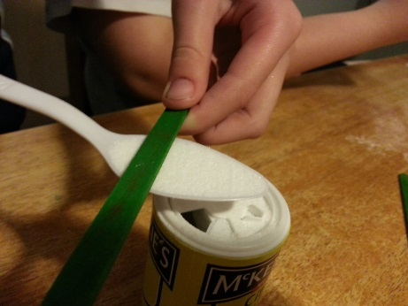
- Add 1 flat teaspoon of bicarbonate of soda to plastic bag. 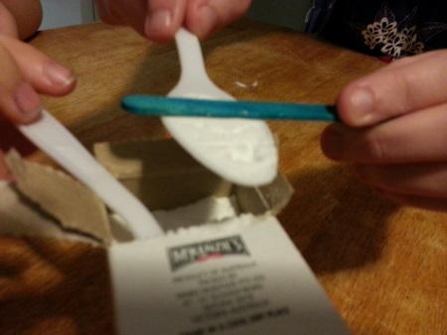
- Now add about 3 heaped spoons of icing sugar. MIX THOROUGHALLY!!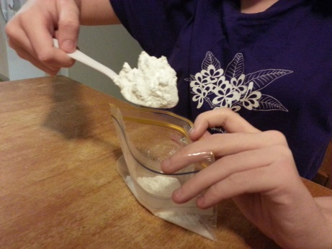
Really mix – make sure there are no blobs or YUCH!! If it’s too fizzy add more sugar. If it’s too salty add more acid, or too bitter add bicarb – but be very careful because the amounts are highly sensitive. If there isn't enough fizz add both bicarbonate soda or citric acid.
Advice:

1. Eat sherbet in small doses! Too much and when you close your mouth it might turn into a dust that flows easily down your windpipe and you might start choking!
2. Have some water handy. Not only to wash down sherbet dust, but also because if your sherbet is too tart, or you failed to mix the bicarb properly, you’ll be grateful to have something to wash your mouth with!

Why it works:
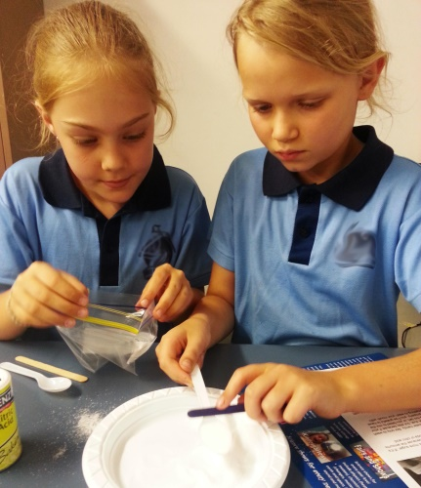
When you combine an acid (in this case the citric acid) and an alkaline (the bicarbonate soda) with water (in your saliva) they mix together to create a gas called carbon dioxide. You are actually feeling the sensation of carbon dioxide bubbles on your tongue.
This is the chemical that makes fizzy drinks fizzy!

Creating science
1/ What effect does adding a heaped spoon of jelly crystals have?
2/ Can you find out how was sherbet invented?
3/ What other uses are there for carbon dioxide gas?

© Dr Joe Ireland, 2015. See www.DrJoe.id.au for more!

