# [Mercury](https://en.wikipedia.org/wiki/Mercury_(planet))

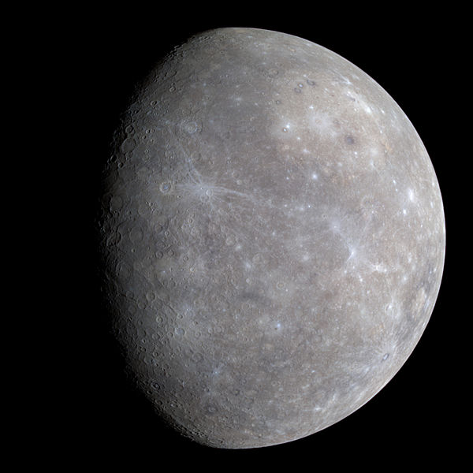

# [Venus](https://en.wikipedia.org/wiki/Venus)

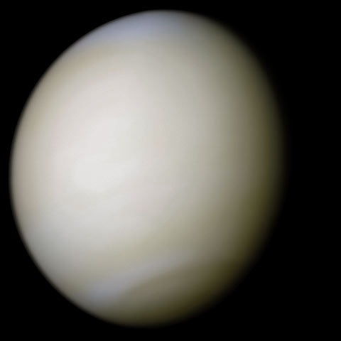

# [Earth](https://en.wikipedia.org/wiki/Earth)

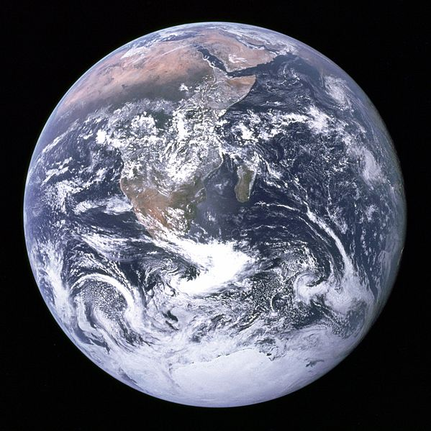

# [Mars](https://en.wikipedia.org/wiki/Mars)

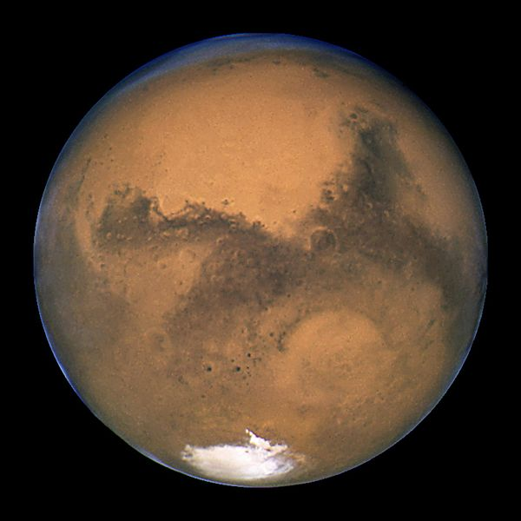

# [Jupiter](https://en.wikipedia.org/wiki/Jupiter)

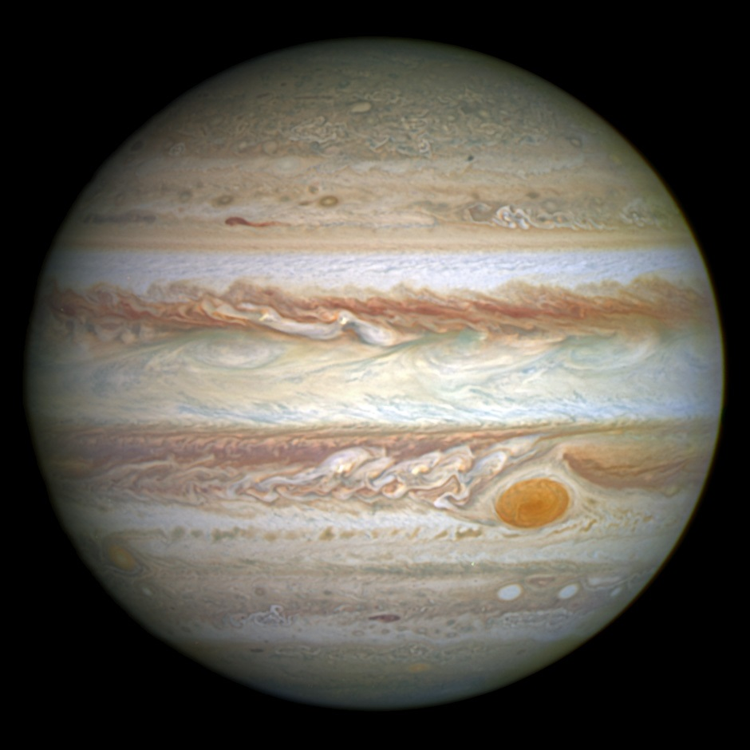

# [Saturn](https://en.wikipedia.org/wiki/Saturn)

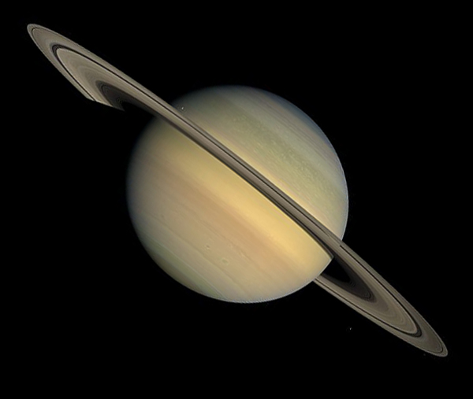

# [Uranus](https://en.wikipedia.org/wiki/Uranus)

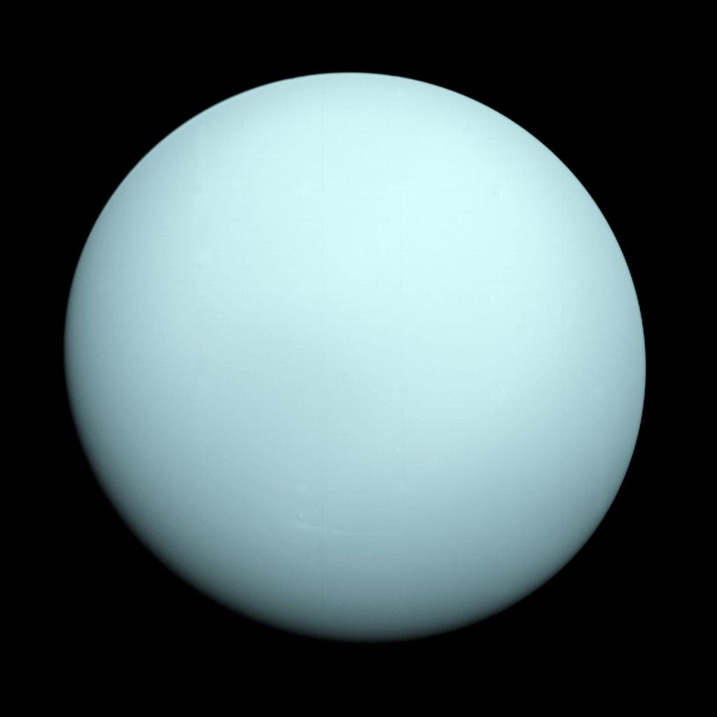

# [Neptune](https://en.wikipedia.org/wiki/Neptune)

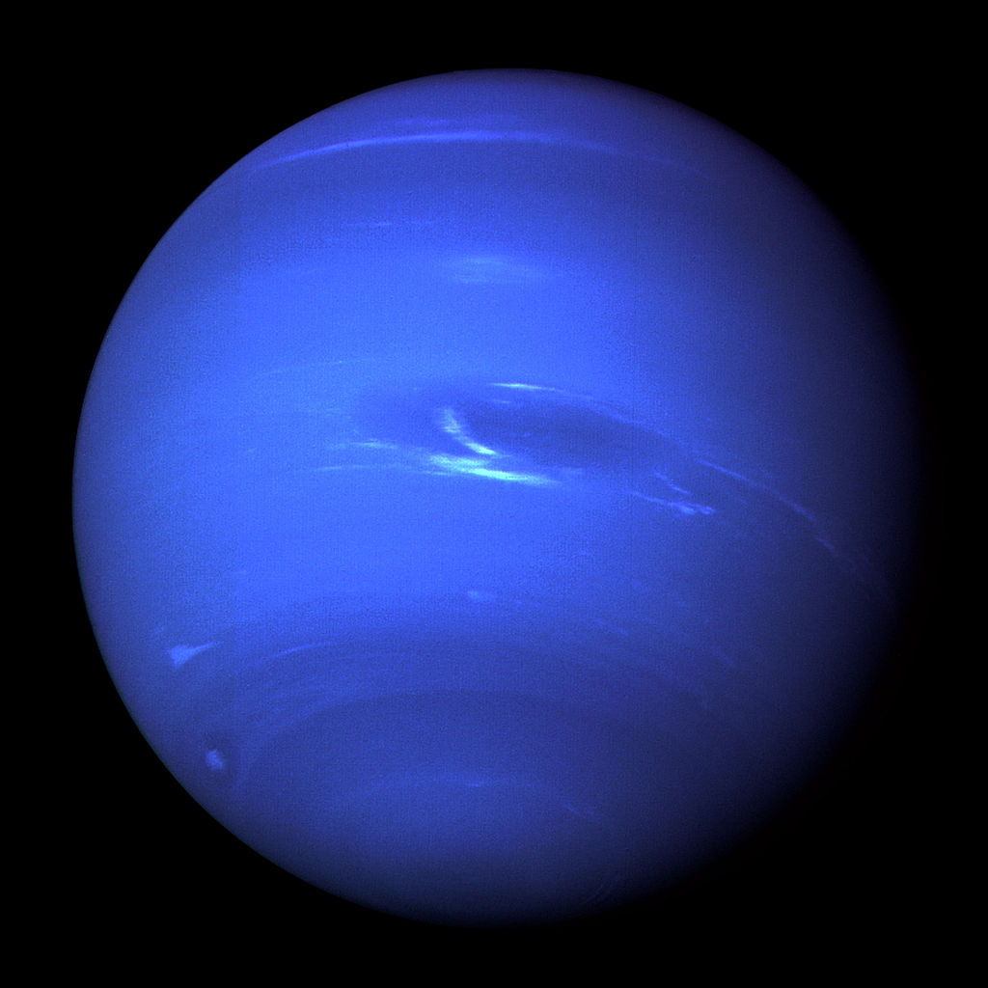

# Pluto

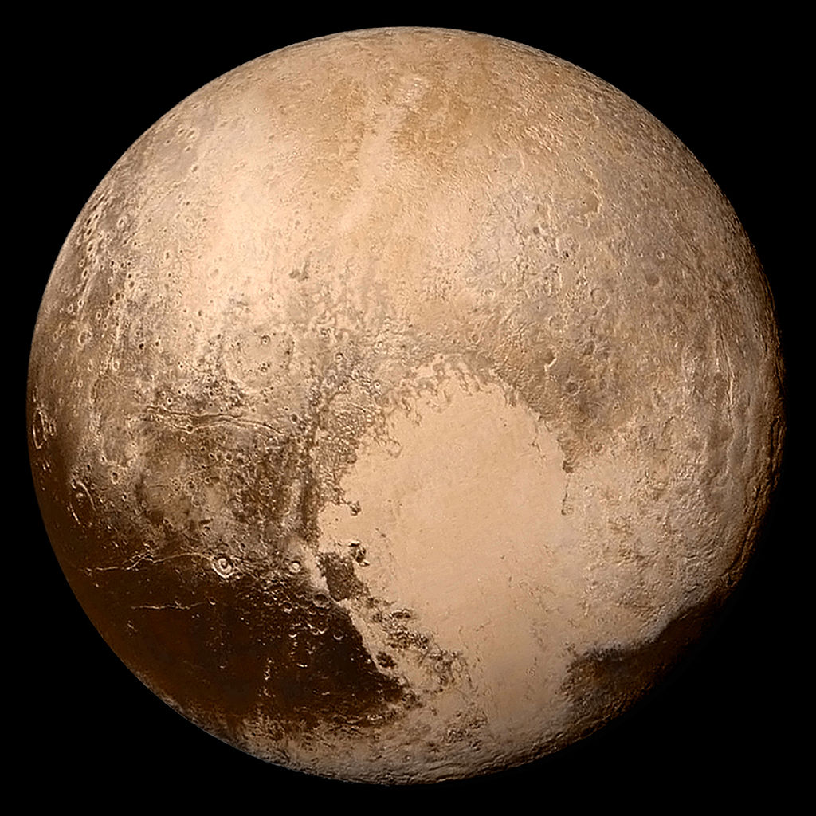

# Eris

