**Dr Joe’s Page of Illusions!**

[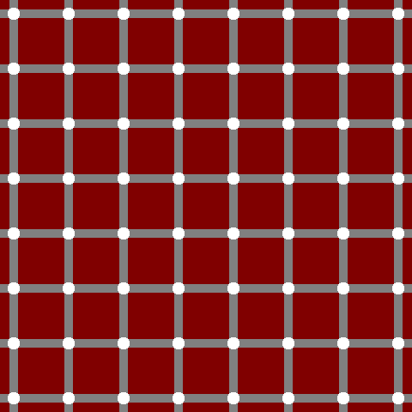](javascript:) 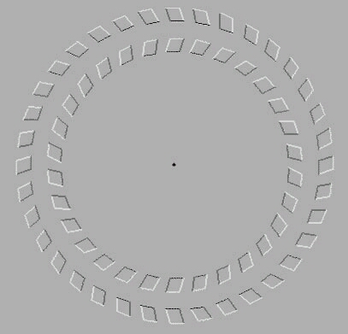

Count the black dots.... Look at the dot and move you head back and forwards…

 

The Three Pronged **Widgit** How many **triangles**? The effect of **context**



**Titchener circles**: Which inside circle Find your **blind spot**: Cover your left eye, look at the circle, move

looks largest? Your head forwards and backwards until the circle disappears!

**

The **Poggendorf illusion** (thin line looks offset, Which **horizontal line** is longest?

but it is aligned, seen also on like the British flag) or are the just the same…

**Make a hole in your hand! Dominant eye**

1. Roll this piece of paper into a tube longways. 1. Look at a spot on the far wall
2. Place the middle of the tube next to your left hand. 2. Both eyes open, cover the spot with your finger
3. Put the tube up to your right eye and look through it. 3. Slowly trace your finger back to your face,

Do you see the ‘hole in your hand’? the place where you stop

is your dominant eye.

© Dr Joseph Ireland 2013 (Dr Joe). See [WWW.DrJoe.id.au](http://WWW.DrJoe.id.au) for teacher notes and more great science!