Summary Curriculum Vitae

Name: | Dr Joseph Ernest IRELAND
Date of Birth | 3 Sep 1974
Home Address: | 14 Wagner rd,  Murrumba Downs,  Qld, Australia, 4503
Telephone: | Mobile +614 1779 5509
Nationality:  Blue card: | Australian  85232/8

Summary of Service
Science education specialist  Science workshops – homeschool | 2002 – now  2013 – now | Touring science shows in primary schools, OSHC, kindergartens, High Schools, and the community. See www.CreatingScience.Org  Designing, promoting and presenting workshops to home school students and parents, using predominantly repurposed and recycled materials to teach simple science concepts. Online and in person.
Sessional Lecturer | 2005 – 2007 | MDB454 Science, technology and society at QUT.  Responsible for student education and assessment.  Helping preservice teachers develop critical reflection skills with relation to Science, Technology and Society.
Academic Liaison officer | 2006 – 2007 | School Liaison Officer for up to 15 schools in Brisbane area  Liaising with schools for the student prac periods 2006-07  Visiting with and counselling preservice teachers.
Avid self-published author | 2004 – now | Writing, editing, publishing and promoting quality young adult novels. Science fantasy and philosophy. www.DrJoe.id.au
Supply teacher | 2003 – 2007 | Elementary and Secondary teaching
Secondary science maths teacher | 2000 – 2001 | Science and Maths teacher  Tennant Creek Primary School, Northern Territory

Academic Qualifications
Doctorate of Philosophy | Queensland University of Technology, 2011
Masters of Education | Queensland University of Technology, 2006
Grad. Dip. Ed. (Sec) | Ballarat University, 1999
B.Sc. (Psych) | Victoria University, 1998

Career Objective
My teaching focuses on empowering students and teachers to critically and independently access knowledge and knowledge sources, and to develop the willingness and ability to asses and experiment on various knowledge claims for themselves. My service revolves around promoting science and scientific ways of thinking in the community, and in providing professional development opportunities to teachers and the community in line with my teaching foci. My stewardship is embedded in a deep commitment to the worth and potential of every human being, and in empowering others as creative and critical thinkers with an abiding sense of self-esteem.
Research directions;
- Exploring practicing teacher’s conceptions of Inquiry Learning, their techniques of implementation, and the resultant effectiveness. I also wish to understand more about the student’s experiences and responses to Inquiry Learning, as well as the educative outcome of such.
- Managed Danger – helping students and teachers, even in early childhood education, to safely access STEM, as well as gain vital danger management efficacy and skills.
- What are the contributions of masculine ways of knowing, learning and teaching in the EC Curriculum?
- Can four year olds understand the concept of Density?

Areas of Expertise
Interests are focussed on understanding:
- Teacher understanding and implementation of inquiry based learning methods in the curriculum, particularly with regard to science education.
- Social processes involved in the creation and communication of knowledge, and the socially responsible use of that understanding to bring about effective and emancipatory change.

Teaching responsibilities relevant to this tender
- Delivery of professional development programs in inquiry education in science
- Support of public understanding through print and visual media
- Supervision of post-graduate candidates in topics relevant to education
- Teaching in such subjects as Science pedagogy and Philosophy of Science.

Professional Affiliations, Roles and Responsibilities:
Editorial Reviewer
IJSE – editorial team the International Journal of Science Education.
RISE – editorial team Research in Science Education.

Research Publications
C1 - Journal Article (Scholarly Refereed)
Ireland, Joseph E., Watters, James J., Brownlee, Joanne M., & Lupton, Mandy (2014) Elementary School Teacher’s Approaches to Teaching Science through Inquiry, International Journal of Science education.

Ireland, Joseph E., Watters, James J., Brownlee, Joanne M., & Lupton, Mandy (2012) Elementary teacher’s conceptions of inquiry teaching : messages for teacher development. Journal of Science Teacher Education, 23(2), 159-175.

Ireland, Joseph, Tambyah, Mallihai, Neofa, Zui, & Harding, Terrence (2009) The tale of four researchers: trials and triumphs from the phenomenographic research specialization. In Jeffery, P (Ed.) Proceedings of the Australian Association for Research in Education (AARE) 2008 International Research Conference. Changing Climates: Education for Sustainable Futures. The Australian Association for Research in Education, Online, pp. 1-15.

E1 –Conference: Full written paper - refereed proceedings
Ireland, J. (2010). Teachers' conceptions of how to engage students thought inquiry leaning: Foundations for STEM. Paper presented at the Science Engineering Mathematics in Education (STEM). 26-27 November, Brisbane: Queensland.

Ireland, J. (2008). ‘Inquiry learning is… difficult to define!’: Primary school teachers’ conceptions of teaching science through inquiry learning. Paper presented at the annual conference of the Australasian Science Education Research Association (ASERA). 2-5 July, Brisbane: Queensland. Available at http://eprints.qut.edu.au/view/person/Ireland,_Joseph.html

E2 - Conference Paper (Full Paper, Non-Eligible)
Ireland, Joseph (2019) “The tragedy of tragedy.” Publicshed in ECTA journal 2019

Other publications and scholarly works
Creating Science (2018) a handbook of science experiments and activities. Produced with the assistance of home schooling students of Brisbane surrounds.

Ireland, Joseph E. (2017) Doing what we do better than we’ve ever done it: Simple ideas for Enriching the Science Curriculum. Published online 5 October 2017

Space Chase: Arrendrallendriania. Young adult science fiction series. Real science weaved around an engaging narrative.

Choice, set free: Quest of the Tae’anaryn. Youth fantasy novel. Focuses on bullying, self-esteem and existential questions. A challenging read for the young philosopher.

Professional References
Jim Watters Thesis supervisor
Unit co-ordinator MDB454
Associate Professor QUT
(W) 3818 3639
(M) 041 464 3639
J.Watters@qut.edu.au

Joanne Brownlee Lunn Associate thesis supervisor - research
Associate Professor - QUT
(W) 3138 3080
(M) 0409 141 848
j.lunn@qut.edu.au

Ecclesiastical References

Abraham McDade Bishop (pastor) of local LDS faith
(m) 0419 668 243
abe.bec@bigpond.com

Professional Development Presentations

“Creating Science” presentations 2016: ECTA, Lady Gowrie, ConASTA conferences. ECTA

“Dr Joe’s Inquiry conQEST 2012 for Queensland Education Science Technicians
Science for teachers”

“Great Ideas for Workshop presented at a teacher education day
Teaching Physics” by Science Time education. 2008.

“Great Ideas for Workshop presented at a teacher education day
Science Teaching” by Science Time education. 2007.

Contact Details
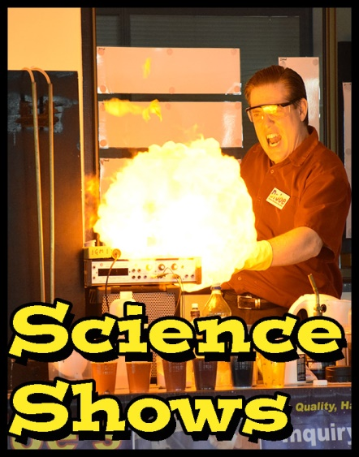
Name: Dr Joseph Ireland
Citizenship: Australia
Mobile: 041 779 5509
E-mail: joe@DrJoe.id.au

URL: www.DrJoe.id.au

Science is fun,
Science is purposeful,
Science is emancipatory.

