Creating Science – Sense of Sight.
What you see, and how you make sense of what you see, are very different things!

Suggested outcomes
Science Inquiry Skills, Planning and conducting F: Participate in guided investigations and make observations using the senses.
Science Content, Physical sciences 1: Light and sound are produced by a range of sources and can be sensed.
Science Inquiry Skills, Questioning and predicting 4: With guidance, identify questions in familiar contexts that can be investigated scientifically and make predictions based on prior knowledge (ACSIS064)
Science as a human endeavour 7, Use and influence of science: Scientific knowledge is used to solve problems and inform personal and community decisions (ACSHE100)

Warning
- Be careful with eyes! Some activities require students to look through things, bringing them close to their face. Help students understand and exercise eye care and first aid if necessary.

Preparation
- Prepare a group of illusions for students to enjoy. There are plenty online, and in real life such as:
  - The Poggendorf illusion – the British flag (on a corner of the Australian Flag)
- You might like to print out, or present on a tablet computer, the images in this document at some point. Please have such a device ready with the information already downloaded.

Engage
Remind students that:
- Today we’re going to have some FUN with vision – remember, this is NOT a professional diagnosis in any way. If you are concerned about your vision or perception in any way, please see your health care professional.
Show them the ‘Oh it’s a hippo’s head’ at the end of this document.
- After a giggle, ask: why did you think the man said that?
Explain: this is an example of visual constancy.

Explore
Ask
- You see half a cat, do you believe the other half is still there?
- A hand grows larger in our visual field – is it growing, or getting closer?
- Does the sun move below the horizon? Copernicus and galileo had to convinced us otherwise.
Ask: what is this an example of? (Visual perception)
Explain: what we see, and how we make sense of what we see, are very different things! First, let us explore seeing.

Explain
Explain: Our sense of sight is, for most humans, our most important and dominant sense. Every part of that sense needs care and protection, and professional medical help when things go wrong.

How it works
- Light comes in through the clear cornea (it gets its oxygen supply directly from the air and has no blood vessels, thankfully!)
- Passes through the small hole known as the pupil, which can chance its shape to let in more or less light.
- Is focused by the lens, which can change shape as the muscles around it contract and relax. As we get older the lens gets firmer, making it harder to focus.
- The light shines through the vitreous humour (Latin for ‘glassy fluid’ – yup, it’s like jelly, but it helps to keep the eye inflated and less prone to popping if it was full of air).
- The image flips upside down and back to front to land on the retina, which is a kind of screen that detects light. It has two kinds of detectors, rods and cones.
  - Cones correspond (roughly) to red, green and blue. (They also block out the opposite colour, which is why we can get the after image effect.)
  - Rods are sensitive to any kind of light, and are particularly effective at low levels, such as at night.
- The retina turns those light pulses into electrical signals, and sends it towards the brain
  - The focal point of the retina is an indent called the fovea. It has no rods, and an intense collection of cones.
- The nerves that send the light to the brain are called the optic nerve. This nerve also helps to process the information, helping define edges and recognisable shapes and motion.
- The nerve passes through the mid brain, where the information from the left side of your body is passed to the right side of the brain, and the information from the right side of your body is passed to the left side of the brain. Why? To give it more time to organise and interpret information from all the senses. The mid brain reacts very quickly to threats, but does not think about them very much.
- The nerve (and associated nerves) end up at the optical cortex, located at the back of the head. Here is where the actual seeing happens, as opposed to detecting light.

Elaborate
There are loads of fun ways to trick our visual ability.

Perceptual constancy
From birth and perhaps even before that, our brain needs to learn a whole bunch of tricks and schematics for organising what it sees with what it expects about reality.
One trick is perceptual constancy – the theory that an object will continue to maintain certain characteristics even when appears to change, or even when the object disappears completely.
- For example, as an object gets nearer to our face, it appears to grow in our visual field. Is this because it is actually getting bigger? Babies soon learn that visual size often indicates closeness, not actual size. (We still have a blinking reflex to keep us safe, however).
- Also, seeing the head of a cat, especially one that is moving as though it is alive, means that the rest of the cat is there, but not visible.
- And when someone places an object under a cup, the object is still there, but it no longer visible.
These are examples of perceptual constancy.

A still world
Are you on a moving world?
What does it mean when the sun goes below the horizon – has it moved, or you?
Galileo and others convinced science that, despite the evidence of our senses, the earth moves and not the sun (relative to each other, at least).
But it doesn’t feel like it, because it is a very smooth ride!
Or is this a better example of an equilibrium illusion than a visual one?

After image
Stare at any picture for around 30 seconds – eyes not moving, then shut your eyes tight. You will get a reverse colour image of the picture. This is because our eyes, like most of our senses, acclimatise to certain sensations over time. Our eyes are constantly moving to try and overcome this tendency, and we almost never notice! (some eyes move way too much, and that’s a problem too)
Taken 15 may 17 from https://www.moillusions.com/black-and-white-spanish-castle-in/

Dominant eye
- Look at a spot on the far wall
- Both eyes open, cover the spot with your finger
- Slowly trace your finger back to your face, while covering the image at all times. You will end up pointing at only one eye - your current dominant eye.
Just like many of us have a dominant hand that we tend to use the most, with the other one coming in for support, we often have a dominant eye that does a majority of the perception work.
Sometimes one eye (and its associated brain tissues) becomes so lazy it will all but stop seeing completely. This can be a big problem in young children – easy enough to fix, they just have to wear an eye patch over their good eye for a few hours a day to get their lazy eye working like it should.

Colour vision
Ishihara plates taken 15 may 2017 from Public Domain, https://commons.wikimedia.org/w/index.php?curid=1696003

Bifocal vision
Our brain has to combine two separate images, one from each eye, into a coherent image. We can have a lot of fun with that!
- Try the ‘hole in the hand’ activity from the hand out.
- Try the ‘floating finger’ activity.
- Try the 3d images from 2d pictures, found in books or the internet.

* Our blind spot
While our fovea is the place our eyes use to focus on details, the fact is the nerve endings run over the TOP of the retina, and not underneath it (I don’t yet know why!)
All those nerve collect together, and need to exit the eye somewhere so they can make their way to the brain. That place is called the optic nerve, and where it leaves the eye there’s no room for a bundle of rod or cone cells – SO THAT PART OF EVERY HUMANS EYE IS BLIND.
But what’s even more amazing, is that we are BLIND TO BEING BLIND – our brain covers up that gap using the image from the other eye, so that we rarely even notice it. Activities like the following can help bring out the blind spot. With practice you can find it any time you like, but you need to keep one eye closed!
- Find your blind spot: Cover your left eye, look at the circle, move your head forwards and backwards until the star disappears! (at about 30 centimeters).

Having trouble? Don’t despair! It’s very tricky the first few times!
- Try this: Cover your right eye, look at the star, move your head forwards and backwards until the circle disappears!

Impossible object
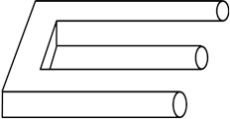
Art that, in part makes sense, but as a whole would be physically impossible.
Wikipedia: “The unsettling nature of impossible objects occurs because of our natural desire to interpret 2D drawings as three-dimensional objects.”
The artwork of M.C.Escher is a great example – look it up!

And many more!
Enjoy many illusions, and try to figure out how they trick our brain. You may need to research your own questions on line.

Evaluate
Explore sicknesses and illnesses that can damage or destroy human vision, the things we are doing to help overcome them, and what we still don’t know.
Using your knowledge of visual and perceptual illusions, do you think that you might be able to create your own?

Creating science
The mechanics of human sight, including the eyeball, optic nerve, and visual cortex.
Ways in which we fool our human perception, such as visual illusions.

Appendix – look, it’s a hippopotamus
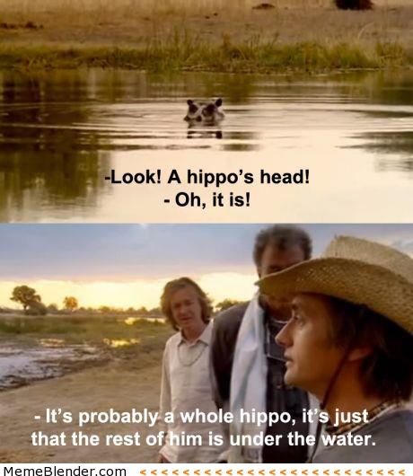
\taken 15 may 17 from http://imgur.com/gallery/CfY5zAL

Appendix – Ishihara plates
Ishihara plates taken 15 may 2017 from Public Domain, https://commons.wikimedia.org/w/index.php?curid=1696003. If you are concerned about your colour vision, please see your health care professional.
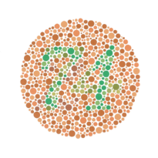
Example of an Ishihara color test plate. The number "74" should be clearly visible to viewers with normal color vision. Viewers with dichromacy or anomalous trichromacy may read it as "21", and viewers with monochromacy may see nothing.
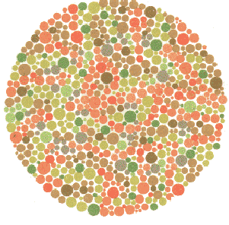
Ishihara Plate No. 19 (Nothing (hidden digit plate); Red-Green deficiency sees 2)
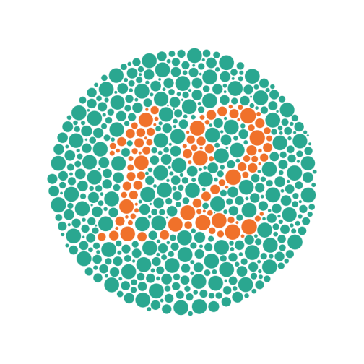Plate 1 – most people see the number 12.

Appendix – our beautiful eye
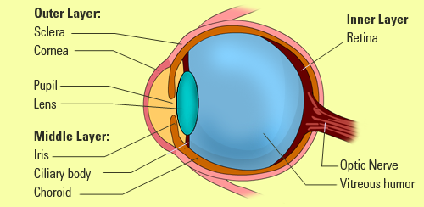
Taken 15 may 17 from http://eschooltoday.com/science/the-five-senses/the-sense-of-sight.html

I once knocked a glove from the top shelf of my cupboard. On its way, flailing down, it looked maybe just a little like a spider. By the time it hit the ground I’d already realised it was just a glove, but my mid brain was too quick to judge, and I leapt back anyway!

